T
Howth Yacht Club
In association with
Irish University Sailing Association
IUSA Student Yachting Nationals 2018 incorporating the SYWoC/ World University Sailing Championship Qualifiers for 2018
Date: 7th & 8th April 2018
Sailing Instructions
The IUSA Student Yachting Nationals 2018 is also a qualifying event for either SYWOC or the World University Sailing Championship 2018. The Organising Authority is Howth Yacht Club (HYC), in association with the Irish University Sailing Association (IUSA).
1. Rules
1.1 The event will be governed by the rules as defined in the Racing Rules of Sailing (RRS) and the J80 Class Rules except that there is no requiremwnt for participants to be members off the Class Association..
1.2 The prescriptions of Irish Sailing will apply.
1.3 Boats will carry the sails as instructed by the Race Committee, as signalled in accordance with SI 6.2. Only equipment and sails provided with the boat may be used. No changes shall be made to rig settings, forestay length or spreaders. Failure to comply may result in disqualification from a race or the series.
1.4 Competitors shall report any damage or loss of equipment, however slight, to the OA’s representative or protest committee immediately after the race where the damage occurred. The penalty for breaking this SI may be disqualification from the race(s) in question, unless the protest committee or OA is satisfied that the competitor made a determined effort to comply.
1.5 In the event of a conflict between the Notice of Race and these Sailing Instructions, these Sailing Instructions shall take precedence.
2. Notice to Competitors
Notices to competitors will be posted on the official regatta notice board in Howth Yacht Club. This is at the side of the Marina Office on the ground floor.
3. Changes in Sailing Instructions
3.1 Changes in Sailing Instructions will be posted before 09.00 on the day they take effect, except that any change to the schedule of races will be posted by 20.00 on the day before it will take effect.
3.2 Notwithstanding the provisions of SI 3.1, changes to the Sailing Instructions may be instructed orally on the water, including by VHF on the channel designated for the event. Such oral changes will be communicated to each boat before the Warning Signal of the race for which the change takes effect. This includes changes to the Race Schedule.
4. Signals made ashore
4.1 Signals made ashore will be displayed from a flagpole at the top of the Marina ramp.
4.2 When flag ‘AP’ is displayed ashore, ‘1 minute’ is replaced by not less than 45 minutes in the race signal AP.
5. Schedule of Races
5.1 A briefing will be held for all competitors near the HYC Race Office at 0830 on Saturday, 7th April 2018
5.2 Refer to Appendix B for Schedule of Races
5.3 The scheduled time for the warning signal of the first race is 1000 on both days
5.4 The Warning Signal of a race will be not be given after 1600 on Sunday
6. Signals from the Committee Boat
6.1 The Class Flag will be Code Flag Q.
6.2 Before the Warning Signal the Race Committee will signal the sail combination to be used. The signals shall have the following meanings:
- Flag ‘A’: Jib, full main and spinnaker
- Flag ‘B’: Jib, reefed main and spinnaker
- Flag ‘C’: Jib and reefed main only (no spinnaker).
This information may also be relayed via VHF
7. Racing Area
The racing area will be to the north of Howth Harbour.
8. The Course
8.1 The diagram in Appendix A shows the courses, including the approximate angles between legs, the order in which marks are to be passed, and the side on which each mark is to be passed. No later than the warning signal the race committee will indicate which course is to be sailed.
9. Marks
9.1 Rounding marks will be black inflatable marks.
9.2 The starting mark will be an orange pillar mark. The finishing marks will be a cherry mark.
9.3 In order to protect the integrity of the course, the Race Committee at their sole discretion, may amend the position of the marks without signalling. This changes RRS 33.
10. Harbour Traffic
Fishing vessels and other powered craft have right of way in the channels leading into and through Howth Harbor. Competitors shall keep clear of all such craft and, in the event of any competitor breaching this requirement, they may be excluded from the event or have such lesser penalty imposed as deemed appropriate by the Protest Committee (this changes RRS 64.1). Breach of this rule is not grounds for protest by another boat.
11. The Start
11.1 The Warning Signal shall be given three minutes before the Starting Signal. The Preparatory Signal shall be given two minutes before the Starting Signal. The One Minute Signal shall be given one minute before the Starting Signal. (This changes RRS 26)
11.2 The starting line will be between a red and white pole on the Race Committee Vessel and the starting mark.
11.3 The Race Committee may broadcast individual and general recalls on VHF. Failure to make or receive a broadcast shall not be grounds for redress. This changes 62.1(a)
11.4 A boat shall not start later than 3 minutes after her Starting Signal.
12. Shortening the course
12.3 The course may be shortened for any reason at the discretion of the Race Officer in accordance with RRS 32.2. Should he wish to shorten a race to finish upwind or downwind at the start/finish line (the boats having finished one or two rounds), it will be signalled by displaying code flag “V” from a RIB adjacent to the preceding mark, accompanied by repeated sound signals. This changes and amends the RRS Race Signals.
13. Penalty System
13.1 RRS 44.1 is changed so that the Two-turn Penalty is replaced by a One-turn Penalty.
13.2 When the Protest Committee decides that a boat that is party to a hearing has broken a rule (except RRS 2, the rules of Part 2, RRS 28 and 31), the penalty may vary from a Scoring Penalty of 10% (calculated according to rule 44.3(c)), to disqualification, at the discretion of the Protest Committee.
13.3 Protest Committee on the water
This Sailing Instruction does not change the Basic Principle of Sportsmanship and the Rules that competitors in the sport of sailing are governed by a body of rules that they are expected to follow and enforce. The presence of the Jury on the water is intended to reinforce not replace self-policing.
a) i) When a Protest Committee member sees an incident in which he believes a rule of Part 2 or RRS 31 has been broken, he may inform the boats involved by making a sound signal (whistle), and displaying a red flag.
ii) If following;
- action by the Protest Committee under sailing instruction 13.3(a) (i)
- a protest by a boat,
no boat takes a One Turn Penalty under rule 44.1 (modified by SI 13.1), the Protest Committee may then penalise one or more boats without a hearing. The penalty will be signalled by a sound signal (whistle) and displaying a red flag. The Protest Committee member will hail or signal to identify each boat penalised.
iii) When a Protest Committee member penalises a boat under SI 13.3(a) ii, SI 13.1 will not apply and the penalty will be a Two Turns Penalty, according to RRS 44.2.
b) When a boat fails to take a penalty signalled by a Protest Committee member under SI 13.3(a) iii, she will be disqualified without a hearing.
c) There shall be no request for redress or to reopen a hearing or appeal from a decision hailed by a Protest Committee member under SI 13.3(a) iii. This changes RRS 62, 66 and 70.
Action or non-action by the Protest Committee cannot be ground for redress (RRS 62.1(a)), request to reopen (RRS 66), or appeal (RRS 70).
d) There shall be no request for redress based on a claim that an action by a Protest Committee boat was improper. However, the Protest Committee may consider giving redress when it believes that an official boat, including a Protest Committee boat, may have seriously interfered with a competing boat.
e) Except when a penalty is signalled under SI 13.3(a) iii the rules of Part 5 Protests, Redress, Hearings, Misconduct and Appeals apply. Boats, the Race Committee and Protest Committee have the right to protest and request redress. The Protest Committee may take action under RRS 69.2 at any time.
f) If after signalling a penalty under SI 13.3(a) iii, the Protest Committee learns that that the incident may have resulted in injury or serious damage, SI 13.3(e) does not apply and the Protest Committee may protest a boat under rule 60.3(a)(1).
14. The Finish
The finishing line shall be between the main mast of the Committee Vessel, displaying a blue flag and the finishing mark.
15. Time Limit
15.1 The time limit for the first boat to sail the course and finish shall be 45 minutes.
15.2 Boats failing to finish within 10 minutes after the first boat sails the course and finishes will be scored Did Not Finish without a hearing. This changes RRS 35, A4 and A5.
15.3 After the first boat has sailed the course and finished, the Race Committee may offer a finishing position to the last placed boat still racing. The boat will be scored as if her position in the race at the moment the offer is made is her finishing place. A boat is not obliged to accept such an offer. A boat that accepts the place offered will immediately sail to the start/finish line and shall not continue in the race. The Race Committee may repeat this process with the next and subsequent boats. This changes the definition of the word "Finish". This changes RRS 35 and A4
16. Protests
16.1 Protests forms are available at the race office. Protests and requests for redress or reopening shall be delivered there within the time limit.
16.2 The protest time limit each day is sixty minutes after the last boat has finished the last race of the day or the race committee signals no more racing for the day, whichever is the later.
16.3 Notices will be posted no later than 15 minutes after the protest time limit to inform competitors of the time and place of hearings in which they are parties or named as witnesses.
16.4 Notices of protests by the Race Committee or Protest Committee will be posted to inform boats under RRS 61.1(b)
16.5 Breaches of SI 18 will not be grounds for protest by a boat. This changes RRS 60.1(a). Penalties for these breaches may be less than disqualification.
16.6 Gear failure will not be grounds for redress. In the event that any boat suffers gear failure or damage which precludes that boat, or any crew assigned to race in it, from completing the series, the Organising Authority may amend the schedule or overcome the consequences of the failure / damage as they deem necessary for the conclusion of the event, up to and including the exclusion of entered crews from further participation.
17. Scoring
17.1 The Low Points scoring system of RRS Appendix A will apply.
17.2 If five or fewer teams enter the competition the series will consist of up to ten races. If more than five teams enter the teams will be divided into flights. Each flight will have up to five races each. The final shall be contested by the top two boats from each flight with eight races scheduled. The better third placed team may be offered a place in the final at the discretion of the Race Committee. In the event of adverse conditions or unavailability of the required number of boats, the Race Committee may adopt an alternative competition format or scoring system to determine the winner.

17.3 When fewer than 4 races have been completed, a boat’s series score will be the total of her race scores.

17.4 When more than 4, but fewer than 8 races have been completed, a boat’s series score will be the total of her race scores excluding her worst scores.
17.5 If 8 races, or more, have been completed, a boat’s series score will be the total of her race scores excluding her two worst scores.
17.6 The qualifying races and the final races will be scored as two separate series. If it is not possible to sail a final series, the winner and runner up may be determined on the basis of the best scoring crews from the qualifying series.
18. Safety Regulations
18.1 Personal Flotation Devices shall be worn at all times by competitors whilst afloat, except briefly while changing or adjusting clothing or personal equipment. Wet suits and dry suits are not personal flotation devices. ICF ‘Y’ will not be displayed. This changes RRS 40.
18.2 A boat that retires from a race shall notify the Race Committee as soon as possible.
19. Radio Communication
It is strongly recommended that all yachts carry a VHF radio. Communication on general matters relating to racing and safety may be transmitted by the race committee. The Race Committee will inform competitors at the briefing which channel will be used for these communications. The Organising Authority will not provide VHF radios for competitors but each competing crew shall be deemed to have a functioning VHF radio and be keeping watch on the designated VHF channel for the event at all times whilst afloat.
20. Prizes
20.1 Prizes will be awarded to the first three teams.
20.2 The winning team will be offered the opportunity to represent Ireland at the Student World Yachting Cup 2018. The offer shall be accepted by 1200 on Monday 14th May in an email to IUSA at iusacommittee@gmail.com. If the offer is not accepted, the opportunity shall be offered to the second-placed team. Communication of this acceptance shall be to IUSA.
21. Disclaimer of Liability
21.1 It is the sole responsibility of the person in charge of each team to decide if that team should race in the prevailing conditions or not. It is the sole responsibility of the person in charge of each boat to decide if that boat should race or continue to race.
22.2 Competitors compete in the event entirely at their own risk – see RRS 4, Decision to Race. The Organising Authority will not accept any liability for material damage or personal injury or death sustained in conjunction with or prior to, during or after the event. The Organising Authority encompasses everyone helping to run the event.

Appendix A: Courses
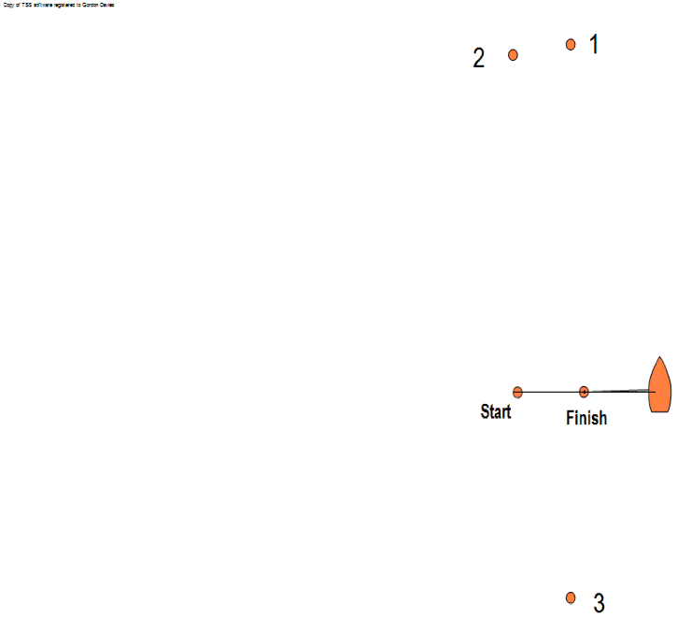

All rounding marks to be left to port.
- One lap course Code Flag 1 displayed
Start – 1 – 2 – 3 – Finish

- Two lap course Code flag 2 displayed
Start – 1 – 2 – 3 – 1 – 2 – 3 – Finish

- Three lap course Code flag 3 displayed
Start – 1 – 2 – 3 – 1 – 2 – 3 – 1 – 2 – 3 - Finish
Appendix B: Schedule

Team 1
Team 2
Team 3
Team 4
Team 5
Team 6
Team 7
Team 8
Team 9
Team 10

Team numbers to be allocated at registration
Rankings to be taken from Student Yachting Nationals 2016

Day 1
Flight 1 | Five races scheduled for each flight. If four or more are completed, one discard will apply.  This schedule may be amended at the sole discretion of the Race Officer | Flight 2
Team 1 |  | Team 2
Team 3 |  | Team 4
Team 5 |  | Team 6
Team 7 |  | Team 8
Team 9 |  | Team 10

Day 2

Final
Winner Flight 1
Winner Flight 2
Runner Up Flight 1
Runner Up Flight 2
*Lowest Scoring 3rd Placed Boat

Eight races scheduled. If four to seven races are completed, one discard will apply. If eight races are completed, two discards will apply. This schedule may be amended at the sole discretion of the Race Officer.

*This place may be offered at the sole discretion of the Race Committee.

