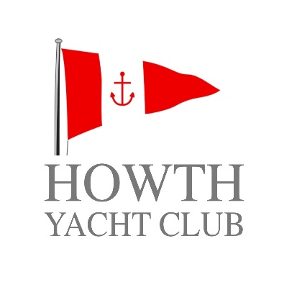
2017 Claremont League

Notice of Race

CHANGE 1

Claremont League Amended Schedule of Races

The following change is now made at Paragraph 4 Schedule of Racing of the Claremont League 2017:

Due to the strong adverse forecast the Races Scheduled for Sunday 10th September 2017 are cancelled and replaced with races on Sunday the 22nd October 2017 the amended race schedule is as follows:

Sunday 17th September 2017
Sunday 24th September 2017
Sunday 1st October 2017
Sunday 8th October 2017
Sunday 15th October 2017
Sunday 22nd October 2017

Marcus Lynch
Hon. Sailing Secretary
Howth Yacht Club
Friday, 8th September 2017

