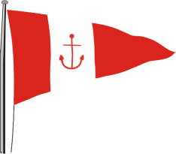 | HOWTH YACHT CLUB  LAMBAY RACES  Saturday 4th June 2016  Supplementary Sailing Instructions for Howth 17s

- Warning Signal
The Warning Signal for the Howth 17s will be at 11.25.

- Courses
Course numbers will be displayed on the starter’s hut on the East Pier. The courses are set out in the table below:
No. 1 | East going to Thulla (J) to port, Lambay to port, Finish at Committee Boat at X Mark in the Sound
No. 2 | East going to Thulla (J) to port, Lambay to starboard, Finish at Committee Boat at X Mark in the Sound
No. 3 | West going, Lambay to port, Finish at Committee Boat at X Mark in the Sound
No. 4 | West going, Lambay to starboard, Finish at Committee Boat at X Mark in the Sound

The Spit Mark must be passed to port heading north and passed to starboard heading south.

- Class Flags
Howth 17s Flag C;

- Start Line
The start line will be between the Red line on the East Pier Starter's Hut and the yellow start mark - "FA" as per the map in the main SIs.

- Finish Line
The finishing line is located in the vicinity of the Spit Mark (S) and the South Rowan Buoy (R) and shall be between a black inflatable mark (FB) and the mainmast (or red/white pole) on the adjacent Committee Boat displaying a blue flag.

