Howth Yacht Club
Laser End of Season Team Challenge and Round the Island Race 2016
Saturday 12th March 2016
Organised by Howth Yacht Club

SAILING INSTRUCTIONS

1. Rules

Racing shall be governed by the Racing Rules of Sailing (RRS), the prescriptions of the Irish Sailing Association and the rules of the Laser class, except as amended by these sailing instructions. Advertising in compliance with ISAF Regulation 20 is permitted.
.

2. Notice to Competitors
Notice to competitors will be posted on the official notice board located in the archway beside the Marina Office.
A Briefing will take place outside the Marina Office at 9.45.

3. Changes to Sailing Instructions
Any change to these Sailing Instructions will be issued by the Race Committee in writing.
Changes will be posted on the official notice board not later than one hour before the scheduled start of the first race affected.

4. Signals Made Ashore
Signals made ashore will be displayed on the flagpole at the top of the Marina Bridge.
When flag ‘AP’ is displayed ashore ‘one minute’ is replaced with ‘not less than 30 minutes’.
Flag ‘L’ with one sound signal indicates an amendment to the Sailing Instructions has been posted.

5. Schedule of Races

If conditions permit, a preliminary race sailed on a Windward Leeward course may precede the Round the Island Race. Numeral 1 displayed on the committee boat will indicate that this race will be sailed. The results from this race will count towards the team prize for the Round the Island Race.
If conditions warrant it, the Race Committee may set a Windward Leeward course instead of the Round the Island race. Flag W displayed on the Committee Boat at the time of the Warning Signal indicates that a Windward Leeward course is to be sailed.

First Warning Signal: 10.45
Start signal for Laser (all rigs): 10.50

6. Class Flags

The Class flags will be as follows:

Laser Standard, Radial & 4.7: Laser Class Flag (All rigs will start together)

7. Racing Area

The racing area will be north of Howth Harbour with the starting lines laid in Howth Sound.

8. The Courses

A Windward/Leeward course will have an offset mark (mark 2) close to the Windward mark. All marks will be left to port.

Lasers – Full Rig and Radials Start - 1 - 2 - 3 - 1 - 2 - 3 - 1 - 2 - 3 – Finish (3 laps)
4.7 rig Start - 1 - 2 - 3 - 1 - 2 - 3– Finish (2 laps)

Note: Marks 1 and 3 designate the Windward and Leeward marks in the sequence of rounding.

It is not necessary to pass through the Finishing line at the end of each round.

In addition to the conventional ‘shorten course’ procedure at a mark of the course, the course may also be shortened by requiring boats to sail directly from a mark to the finishing line. As boats round a mark, flag ‘F’ may be displayed from a nearby RIB, accompanied by repeated short sound signals. Boats shall then sail directly from that mark to the Start / Finish line and finish from the direction of the last mark. This changes Rule 32.2. If flag ‘F’ is displayed from a RIB in the vicinity of marks 1 and 2, the flag shall be deemed to be flown beside mark 2.

The Race Officer may reposition marks during a race to keep the course true to the wind. This will not be signalled. This changes Rule 33.

For the Round the Island race (unless flag W is displayed), the course will consist of a leg to a windward mark, around a spreader mark, both left to port, and then downwind to a Turning Mark. The required side for rounding the Turning Mark for the first time will be advised by hoisting a red or green flag prior to the Warning Signal for the race (diagram attached shows Port rounding on the way to the Island but may be starboard depending on flag hoisted). Boats will proceed to round Ireland’s Eye in a direction of their choice and the Turning Mark shall be left to port before boats sail to the Finish line.

The sequence of mark roundings forming the course for the Round-the-Island Race (unless it is being sailed on a Windward Leeward course) is shown in the appendix. A Hazard Mark (H) will be positioned south of the southern tip of Ireland’s Eye. Boats MUST pass to the SOUTH of this mark between their first and second rounding of the Turning mark (see SI 9) and shall not pass between the Hazard Mark and the Island.

9. Marks

The outer end of the Start Line will be an ORANGE PILLAR mark.
The Finish Mark will be a YELLOW SPHERICAL mark.
Marks 1 and 2 will be an orange spherical.

For a Windward Leeward race, mark 3 will also be an orange spherical but for the Round the Island race it shall be described as the Turning mark and will be a BLACK INFLATABLE mark.

The Hazard Mark off the southern tip of Ireland’s Eye will be a YELLOW INFLATABLE mark.

10. The Start

The starting procedure will be in accordance with Rule 26 (5 – 4 – 1 – GO). The start line will be between the flagpole on the Committee Boat and an ORANGE PILLAR mark.
11. The Finish

The finishing line will be between the flagpole on the Committee Boat and a YELLOW SPHERICAL mark.

12. Time Limit

The time limit for the leading boat in each fleet shall be 90 minutes for the Round the Island race and 60 minutes for a W/L race. Rule 35 is amended so that any yacht that fails to finish within 30 minutes of the first boat of its Class to sail the course and finish will be deemed to have retired (15 minutes for a W/L race).
After the leading boats have finished a race, the Race Committee may offer finishing positions to boats which have not yet finished, starting at the back of the fleet. This changes Rules A4 and A5.

13. Protests

Protests must be made on an official ISA form (available from the Race Office) and lodged within 45 minutes of the last boat crossing the finishing line for the last race sailed.

14. Scoring System

The scoring system will be as per the low Point Scoring System (Appendix A) as follows:
1st = 1 point, 2nd = 2 points, 3rd = 3 points, etc., but points for those falling into the following categories shall be awarded as stated:

DNC scores points equal to the number of entries.
DNS / OCS / DNF / RET/RAF scores points equal to the number of starters in the race.
DSQ scores points equal to the number of entries in the event plus four.

15. Competition and Prizes

Class results for the Round the Island Race shall be provided for each Laser rig size (Full, Radial and 4.7) where there are more than three boats with the particular rig size registered to race on the day.

The Skehan Trophy will be awarded to the winner of the Laser Standard Rig Class in the Round the Island race. A prize will be awarded to the winner of the Laser Radial Class and, provided there are at least three entries, a prize will be awarded to the winner of the Laser 4.7 Class.

The overall Club Challenge trophy will be awarded to the winning team. Teams of three boats will be selected at Registration and will be displayed on the official notice board not later than 45 minutes before the Warning Signal. Team results will be calculated by adding the scores of each member of the team in all races sailed. In the event of a tie on points between teams, the tie shall be broken in favour of the team with the lowest aggregated points score in the last race and, if still tied, the team with the best result by a team member in the last race shall be the winner.

In calculating a team’s total score, where the team is composed of sailors using different rig sizes, the points for each team member shall be calculated by taking their overall fleet position, regardless of rig size.

16. Club Membership

All visiting competitors are granted temporary membership of Howth Yacht Club.

17. Sign out / sign in

For safety reasons, all helms are required to sign out before going afloat and to sign in when coming ashore after racing or having retired. The form will be held in the race office beside the marina office. Failure to do so will incur a penalty, without a protest hearing, equivalent to DNF for the race, or races, for which the boat failed to comply with this instruction. This changes rule 63.1 and Appendix A5.

Safety & Additional Information

Safety

Competitors are reminded of RRS Fundamental Rule 4 'Decision to Race', which reads ‘A boat is solely responsible for deciding whether or not to start or to continue racing’. In reaching a decision, the competitor should bear in mind the fact that the series is a winter event in which wind chill, water temperature and weather conditions can quickly induce fatigue. Personal buoyancy shall be worn at all times. Wet suits shall not be recognised as personal buoyancy. Suitable protective clothing shall be worn at all times.

The Race Committee recommends the following minimum:
3.5 mm long john wetsuit, long sleeve jumper, wind-proof suit, wet suit boots, hat or balaclava or, as an alternative, a dry suit, tee shirt, long sleeve jumper, warm trousers, wet suit boots, hat or balaclava.

All boats shall have a painter, with minimum diameter of 6 mm and at least 3 metres in length, made fast to the bow.

Competitors are advised to regularly cheek their equipment for possible defects, e.g. loose rivets, frayed ropes, insecure bung, loose tiller extension universal joint, split rings, etc.

Competitors shall co-operate with the rescue crew and should accept their advice.

In adverse weather conditions competitors are reminded of the possibility of coming ashore on Claremont beach.

Outside assistance

Boats receiving assistance from official safety boats shall be not be obliged to retire from the race. This changes Rule 41.

Rules of the Road at Sea

When leaving or entering the Marina area and harbour entrance please keep in single file on the right hand side of the channel passing vessels going the other way on your port side. Trawlers have right of way due to restricted waters in the area from the entrance of the trawler dock out to the Rowan Rocks buoy.

Sail Numbers

Sails shall have the correct sail number clearly displayed on both sides in accordance with Class Rules. Permission from the results office shall be requested in writing before going afloat should a competitor wish to sail under a different number from that under which he / she is entered.

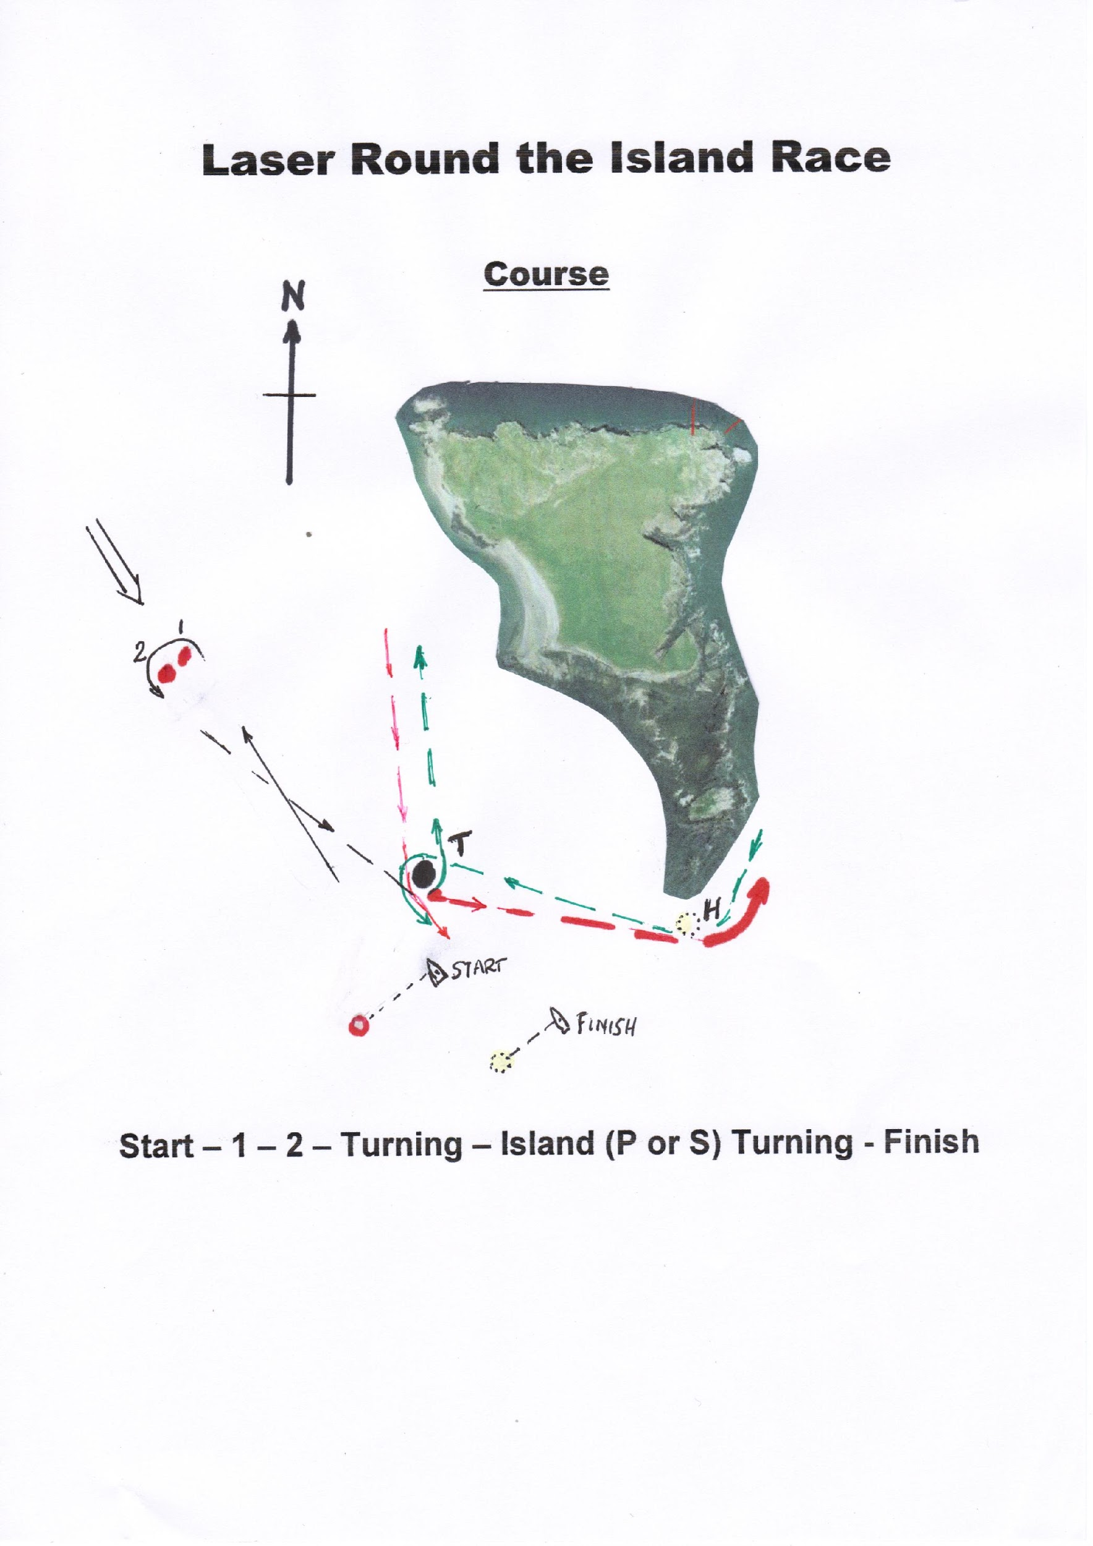
Note:

The above course details will apply where the fleet races around Ireland’s Eye. Turning Mark (T) to be left to port (red flag) or starboard (green flag), as signalled from Committee Starting Boat.

Boats may not pass between mark H and the Island.

