Howth Yacht Club
IUSA Student Yachting Nationals
Saturday 28th and Sunday 29th March 2015

Incorporating the SYWOC Qualifier for 2015

ENTRY FORM

University _______________________________________________________________________________

Helm Name _______________________________________________________________________________

Address _______________________________________________________________________________

_______________________________________________________________________________

Contact No. __________________________ email _________________________________________

Date of Birth __________________________

ENTRY FEE - €250.00
I declare that:
- I agree to be bound by the Racing Rules of Sailing, the prescriptions of the ISA, the Notice of Race, the Sailing Instructions, any amendments thereto and the relevant Class Rules.
- I acknowledge that I enter and sail at my own risk and that Howth Yacht Club is not liable for any loss or damage to boats or equipment or injury to persons.
- I am fully aware of the actual and potential risks involved in active water sports, including drowning, hypothermia and other physical injuries. I accept that, by engaging in active water sports, my physical safety and that of my crew could be endangered. I am also aware that other competitors’ actions and the actions or inaction’s of the organisers of water sports events, including the drivers of escort craft, can also endanger my physical safety.
- I have a valid and adequate third party liability marine insurance policy and I further confirm that this policy will remain in full force and effect for the duration of the event.
- I acknowledge that it is up to me personally to assess whether any event or activity on the water is too difficult for me. I acknowledge that the safety of my yacht and its entire management including insurance is my sole responsibility and I am satisfied that the yacht and helm are adequate to face the conditions that may arise in the course of the races.

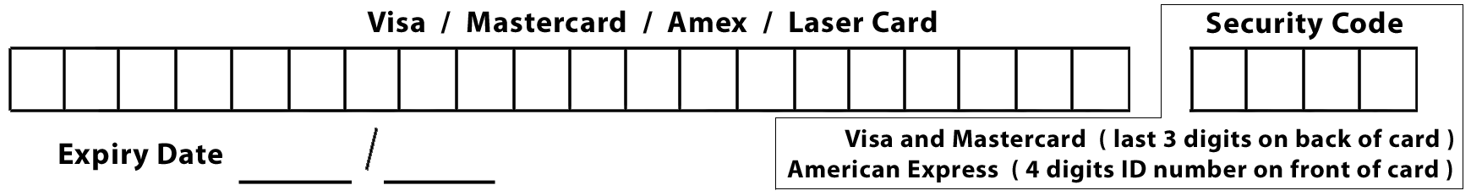

I enclose Laser / Credit Card details / Cheque payable to Howth Yacht Club for € ________

Signed _________________________________________ Date _______________________
Parent or guardian if under 18 years

Entry form with correct remittance to reach
Howth Yacht Club, Harbour Road, Howth, Co Dublin
before competing in the series.

