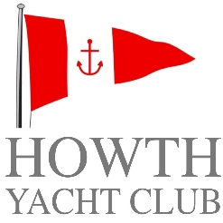 | Brass Monkeys  Winter Series 2021  Sponsored by Bright Motor Group | 

Change No. 2 to Sailing Instructions

As Star Point is out of commission, an alternative committee vessel will be used and we have to introduce changes to the Sailing Instructions as follows:

10. Starting Signals
10.1 is replaced with the following – Racing shall be started in accordance with RRS 26, with classes starting at 5-minute intervals, VHF Radio communications (Ch.77) will replace the displaying of flags.

10.2 is replaced with the following – The starting line will be between the mainmast of the committee vessel displaying an orange flag and a cylindrical orange buoy. An orange inner limit mark may be laid, boats shall not sail between the committee vessel and that mark, any doing so will be disqualified.

15. Finishing
15.1 Replace “red and white pole” with “mainmast”.

18. Courses
18.1 is replaced with the following – Courses will be in accordance with the course card which forms part of these Sailing Instructions. Information regarding the course to be sailed by each class will be given by VHF Radio (Ch.77).

Rupert Jeffares
For Race Committee 12 November 2021

