International J24 Class Association of Ireland
Eastern Championships sponsored by WaterWipes

Saturday 28th & Sunday 29th August 2021

SAILING INSTRUCTIONS

This event is subject to the Covid-19 guidelines as laid out by the Irish Government and in the Host Clubs Covid-19 event protocol document. All people associated with this event must comply with these conditions. These conditions may change as the event approaches and may influence the running/organisation/cancellation of the event.

1. RULES
1.1 The regatta will be governed by the rules as defined in The Racing Rules of Sailing (RRS).
1.2 The prescriptions of Irish Sailing will apply.
1.3 The rules of the International J/24 Class will apply. In particular competitors should note,
a. Class Rule C.1.1, changing Rule 42 (prohibiting hanging off mast or shrouds to promote a roll tack or gybe, and allowing all parts of a main-sheet to be pulled simultaneously)
b. Class Rule C 2.1 Crew Limitations (See also SI 20.1)
c. Class Rule C.2.2, changing Rule 49 (regulating crew position outside the upper lifeline) will apply.
See also SI 20.3 regarding the use of spare spinnakers.
2. NOTICES TO COMPETITORS
2.1 Notices to Competitors will be posted online at
https://hyc.ie/open-events

Protest Committee notices, Protest Time Limits and Protest Schedules will be posted online at
https://www.racingrulesofsailing.org/events/2238/event_links?name=j24-eastern-championships
2.2 The Race Committee (RC) may draw attention to Race Signals given on the Race Committee Vessel and communicate other information on VHF at any time. The RC will transmit on Channel 77 or other such channel as may be displayed on the Race Committee Vessel. Failure to transmit or to receive such communication will not be grounds for redress by a boat. This changes Rule 62.1(a).
3. SPONSORS’ ADVERTISING AND BOW NUMBERS
3.1 World Sailing Regulation 20 will apply.
4. CHANGES TO SAILING INSTRUCTIONS (SI)
4.1 Any change to the SI will be posted before 0900 on the day it will take effect, except that any change to the schedule of races will be posted by 2000 on the day before it will take effect.
5. SIGNALS MADE ASHORE
5.1 Signals made ashore will be displayed on the flagstaff at the top of the Howth Yacht Club marina walkway
5.2 When flag AP is displayed ashore, ‘1 minute’ is replaced with ‘not less than 60 minutes’ in the race signal AP.
6. SCHEDULE
6.1 Competitors' Briefing will take place at 1000 on Saturday 28th August at Howth Yacht Club
6.2 Schedule of Races: 6 Races are scheduled as follows.

Date | Time of first  Warning Signal | Number of Races Scheduled | Low Water  Howth | High Water  Howth
Saturday 28 August | 1130 | Up to 4 | 0942 | 1606
Sunday 29 August | 1030 | Remaining races to complete series | 1025 | 1650

6.3 The warning signal for each succeeding race will be made as soon as practicable.
6.4 On Sunday 29th August, the first warning signal of a race will not be made after 1500.
7. CLASS FLAG
7.1 The class flag will be code flag J.
8. RACING AREA
8.1 Races will be sailed in the waters North of Ireland’s Eye. Competitors are advised to keep a close watch for lobster pot lines in the vicinity of the harbour entrance

9. THE COURSE
9.1 The course will be of the Windward/Leeward type. The diagram in Appendix A shows the course, and the order in which marks are to be passed. All marks shall be left to port, unless a gate has been laid at Mark position 3, where boats must pass between the marks.
9.2 No later than the warning signal, the RC will signal the number of rounds to be sailed. Numeral Pennant 2 signifies 2 rounds and Numeral Pennant 3 signifies 3 rounds.
9.3 No later than the warning signal, the RC may display the approximate compass bearing to Mark 1.
10. MARKS
10.1 Marks 1 and 3 will be large Black inflatable buoys. Mark 2 will be a small spherical buoy.
10.2 The Start Mark will be an inflatable Orange buoy.
10.3 Finish Mark, will be a small spherical cherry buoy.
11. THE START
11.1 Races will be started in accordance with Rule 26.
11.2 The starting line will be between a red and white pole, on the Race Committee Vessel displaying an orange flag at the starboard end and the Start Mark at the port end.
11.3 The RC will attempt to broadcast Individual Recall OCS sail numbers no earlier than one minute after the starting signal, on the designated VHF channel.
11.4 When Rule 30.4 (Black Flag Rule) applies, and following a general recall, the RC may, in addition to the requirements of Rule 30.4, broadcast sail numbers on the designated VHF channel.
11.5 When the RC determines that a boat has not complied with Rules 29.1, 30.2, 30.3,or 30.4 the RC may broadcast the boat's sail number on the designated VHF channel, no earlier than one minute after the starting signal. Failure to broadcast, or errors in the broadcast, will not be grounds for a request for redress by a boat. This changes Rule 62.1(a).
11.6 A boat starting later than 5 minutes after her starting signal will be scored Did Not Start, DNS
12. CHANGE OF COURSE
12.1 Minor adjustments of mark positions will not be signalled by the Race Committee.
12.2 Except at a gate, boats shall pass between the Race Committee Vessel signalling the change of the next leg and the nearby mark, leaving the mark to port and the Race Committee Vessel to starboard.

13. THE FINISH
13.1 The finish line will be between a red and white pole on the Race Committee Vessel flying a Blue flag, and the Finish Mark.
13.2 When the Blue Flag is displayed no boat shall pass through the finishing line, in either direction, except to finish.
14. SHORTENING COURSE
14.1 In addition to Rule 32, a Race Committee Vessel displaying code flag F, making repeated sound signals, is positioned adjacent to a mark of the course, boats, having rounded that mark, shall proceed directly to the Finish line to finish. SI 12.2 will apply.
15. PENALTY SYSTEM
15.1 A boat will take a One Turn Penalty when she has broken a rule of Part 2. This changes Rule 44.1.
16. TIME LIMIT
16.1 The time limit for the first boat to sail the course and finish is 75 minutes.
16.2 Boats failing to finish within 15 minutes after the first boat sails the course and finishes will be scored Did Not Finish without a hearing. This changes Rules 35, 63.1, A4 and A5.
17. PROTESTS, REQUESTS FOR REDRESS, ARBITRATION
17.1 Protests shall be submitted online, within the protest time limit, at https://www.racingrulesofsailing.org/events/2238/event_links?name=j24-eastern-championships
17.2 The protest time limit is 90 minutes after the last boat has finished the last race of the day.
17.3 Notices will be posted online, after the protest time limit, to inform competitors of hearings in which they are parties or named as witnesses. Hearings will be held in the Centenary Room on the second floor of the clubhouse. Parties are asked to wear suitable face covering when attending the hearing.
17.4 Notices of protests by the Race Committee or Protest Committee will be posted online to inform boats under rule 61.1(b)
17.5 On the last day of the regatta, a request for reopening a hearing shall be delivered: -
(a) Within the protest time limit if the party requesting reopening was informed of the decision on the previous day;
(b) no later than 30 minutes after the party requesting reopening was informed of the decision on that day. This changes Rule 66.
17.6 Arbitration will be available in accordance with Appendix T.
18. SCORING
18.1 The Low Points Series of rule Appendix A, will be used.
18.2 Three (3) races are required to be completed to constitute a series.
18.3 One discard will be allowed if four (4) or more races are completed.
19. SAFETY REGULATIONS
19.1 All competitors will wear adequate personal flotation devices at all times when afloat, except briefly while changing or adjusting clothing or personal equipment. Dry suits and wet suits are not adequate personal flotation devices. This changes Rule 40.
19.2 A boat that retires from a race shall notify the RC as soon as possible.
20. REPLACEMENT OF CREW OR EQUIPMENT
20.1 Substitution of crew or damaged or lost equipment is not permitted unless approved by the RC. Requests for substitution shall be made to the RC at the first reasonable opportunity.
20.2 Boats shall sail with their correct sail numbers. Provision to sail under any other number shall be sought in writing from the RC before going afloat and will be granted only in exceptional circumstances. Breaches of this SI may result in protest of the boat by the RC.
20.3 A spare spinnaker may be carried . In the event that the main spinnaker is damaged beyond repair afloat, the spare may be used in subsequent races. Use of the spare spinnaker must be declared by hailing the Race Committee Vessel. This changes Class rule C.10.2.
21. EQUIPMENT AND MEASUREMENT CHECKS
21.1 A boat, crew, equipment and safety equipment may be inspected at any time for compliance with the class rules and sailing instructions.
21.2 Boats may be required to undergo safety/measurement checks on random boats assigned at registration.
22. COACH/SPECTATOR BOATS
22.1 Coach boats shall register with the race office and display such marking as may be required by the RC.
23. HAUL OUT RESTRICTIONS
23.1 Boats shall not be removed from the water between the preparatory signal of the first race and the end of the regatta. In an emergency, and only following a written request, the protest committee may waive this SI.
23.2 In the event of foul weather, the Organising Authority may direct that all boats moored be moved to another berth.
24. DIVING EQUIPMENT AND PLASTIC POOLS
24.1 Underwater breathing apparatus and plastic pools or their equivalent shall not be used between the preparatory signal of the first race and the end of the regatta.
25. RADIO COMMUNICATION
25.1 A boat while racing shall neither make radio transmissions nor receive communications not available to all boats. This restriction also applies to mobile telephones, which shall be switched off while racing.
26. INSURANCE
26.1 Each participating boat shall be insured with valid and adequate third-party liability insurance.
27. PRIZES
27.1 Prize giving will take place as soon as possible following the conclusion of racing.
27.2 Prizes will be awarded to the winners of the event as designated by organising authority. The Gold and Silver Fleet Perpetual Trophies remain the property of the International J24 Class Association of Ireland.
27.3 Keepsake Prizes will be awarded to the following:
Gold Fleet. 1st, 2nd & 3rd. places overall
Silver Fleet: 1st & 2nd places overall
K25 1st place overall
28. LIABILITY
Competitors participate in the event entirely at their own risk – see Rule 3 – Decision to Race. The Organising Authority will not accept any liability for material damage or personal injury or death sustained in conjunction with or prior to, during, or after the event. Howth Yacht Club, including its officers, employees and agents, the race management team, the support boats and anyone helping to run the event shall not be liable for any loss, damage, death or personal injury however caused to the owner/competitor or crew as a result of their taking part in the event.

APPENDIX T – ARBITRATION
B.1 When a protest is lodged, all protests involving a breach of a rule of Part 2 or Rule 31 will go through the Arbitration System.
B.2 If the parties and the designated Arbitrator agree that Arbitration is suitable, the Arbitrator will call a hearing conforming to Section B of Part 5 of the Racing Rules of Sailing, except that the first sentence of Rule 64.1 will not apply. The arbitration shall be binding.
B.3 When the Arbitrator decides that a boat that is a party to the arbitration hearing has broken a rule for which a penalty may be taken at the time of the incident (Rule 44.1), the boat will be offered the opportunity to accept a penalty of 20% calculated according to Rule 44.3(c). No penalty shall result in a score which would exceed that of a disqualification. The protestor will then be invited to withdraw the protest This changes Rule 63.1.
B.4 When a boat has accepted a penalty under B.3 Rule 64.1b will apply at any subsequent hearing regarding this protest.
B.5 When the arbitrator decides that a boat that is a party to the arbitration hearing has broken a rule and that the boat caused injury or serious damage, or gained a significant advantage in the race or series by her breach, that boat will be requested to retire. If the boat does not retire the arbitrator will call a normal protest hearing .
B.6 When there is not an agreement to use Arbitration, or when during or after an Arbitration hearing, the Arbitrator decides that the facts do not allow Arbitration there will be a normal protest hearing, at which the Arbitrator may be a member of the protest committee. Rule 66, Reopening a hearing, will not apply to the arbitration decision.

APPENDIX A – COURSE DIAGRAM (not to scale)

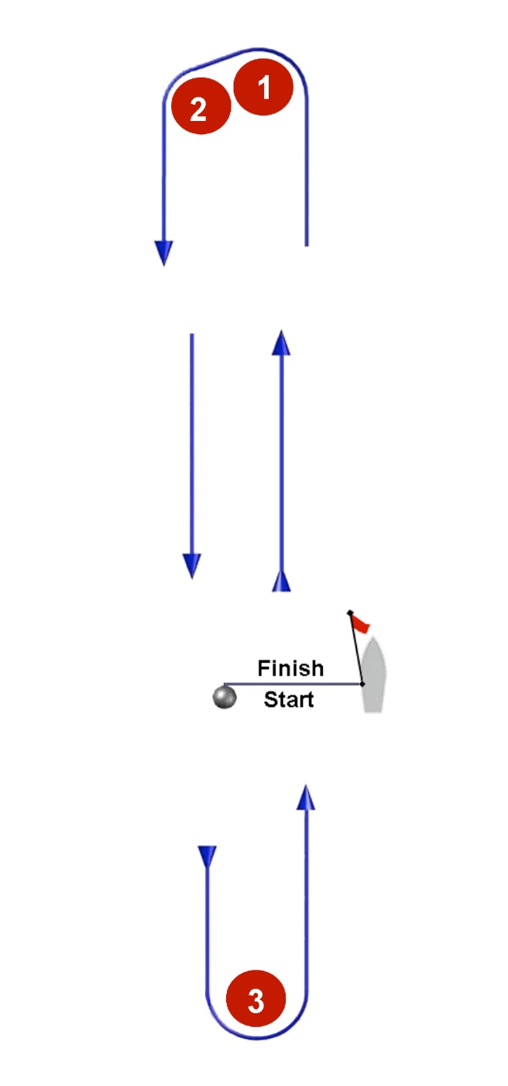
Course Mark Rounding Order

2 Laps | Start – 1 – 2 – 3 – 1 – 2 – 3 - Finish
3 Laps | Start – 1 – 2 – 3 – 1 – 2 – 3 – 1 – 2 – 3 - Finish

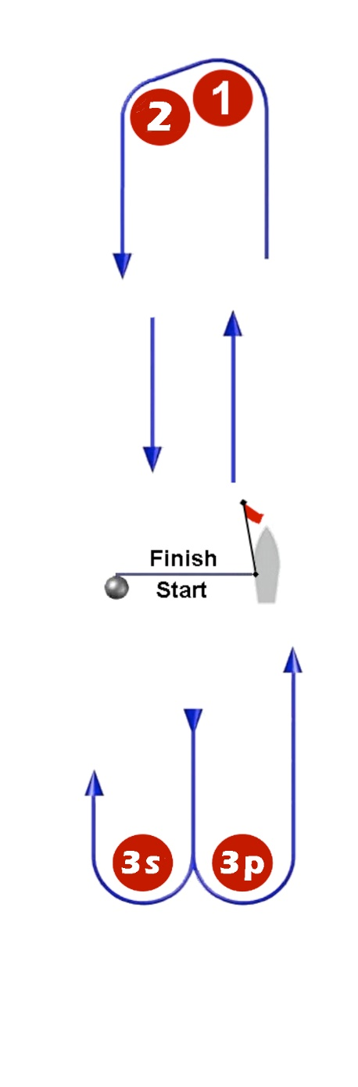
Course Mark Rounding Order

2 Laps | Start – 1 – 2 – 3s/3p – 1 – 2 – 3s/3p - Finish
3 Laps | Start – 1 – 2 – 3s/3p – 1 – 2 – 3s/3p – 1 – 2 – 3s/3p - Finish

