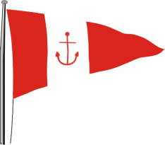 | HOWTH YACHT CLUB  AQUA Double Handed Race  Organised by Howth Yacht Club Ltd.  Saturday 17th July 2021

Race Officer: Scorie Walls

SAILING INSTRUCTIONS

(Could the three boats leading on the water please phone RO on 0872848316 when they are approx. 30 minutes sailing time from the finish line)

- Rules
The races shall be governed by the Racing Rules of Sailing (RRS), Irish Sailing Prescriptions, the Notice of Race, these Sailing Instructions and any amendments thereto. Competitors in IRC and HPH handicap classes shall comply with the rules of those handicapping systems. In the event of a conflict, the Sailing Instructions shall prevail. The crew of each entry is limited to two persons.

- Notices to Competitors
Notices to competitors will be posted on the Official Notice Board located in the archway beside the Marina Office.

- Change of Sailing Instruction
Changes to Sailing Instructions will be posted not later than one hour before the scheduled start of the race. Flag L displayed on the flagpole at the top of the marina bridge denotes that a change of Sailing Instructions has been made.

- Signals Made Ashore
Signals made ashore will be displayed on the flagpole at the top of the marina bridge.
When flag AP is displayed ashore “one minute” is replaced with “not less than 30 minutes” in Race Signal AP. This changes RRS “Race Signals”. Boats are requested not to leave the harbour until flag AP is lowered.

- Race Schedule and Class Flags.
High Water (Howth) 05.16

Class(s) Flag Warning Signal Start
White Sail Cruisers No. 4 09.55 10.00
All Spinnaker Cruisers No. 2 10.00 10.05
J80 J 10.05 10.10
Puppeteer 22 A 10.10 10.15

- Starting Area

(a) The starting area is defined as being bounded by an imaginary line drawn from
the new lighthouse [on the East Pier] to the South Rowan Buoy, to the Thulla Mark to the elbow of the
East Pier.
(b) No boat shall enter this area between the time of the warning signal for the first start and that class’s warning signal. The Race Committee may lodge a protest against a boat that fails to comply.

- The Start

The starting line shall be one of the following, identified by a letter A, or B displayed on the East Pier starter’s hut:

Starting Line A: A line between the red vertical line on the starter’s hut and the South Rowan Buoy.
Starting Line B: A line between the red vertical line on the starter’s hut and Finish Mark F

Should Mark F be missing, flag H will be displayed and boats shall pass south of the Thulla Mark

The sail numbers of boats recorded as OCS may be transmitted on VHF Ch. 69 not less than one minute after her start. Failure to do so will not be grounds for redress.
Any boat starting later than 15 minutes after her Class’s starting signal will be recorded as DNS without a hearing – changes RRS 63.1, A4 and A5.

- Course Designation
Courses will be decided on Friday 16th July 2021 and posted to www.hyc.ie and on HYC notice board. Each course shall be designated by numerals and displayed on boards on the East pier starter hut. The course applicable to each class will be displayed for not less than 4 minutes before its start. This changes RRS 27.1.

- Courses

9.1 Courses will be decided on Friday July 16, 2021 and posted to www.hyc.ie and on HYC notice board and advised on Channel 69 prior to the start. Courses will take in to account the forecast conditions, the class of boat and will aim to provide race duration of approximately 3 hours.
Course to be advised on VHF Channel 69 prior to start, subject to SI 9.4.

(P) Indicates a mark to be left to port
(S) Indicates a mark to be left to starboard

9.2 Where a mark is designated as being passed with a required side, nothing is stipulated about whether the mark is to be ‘rounded’ or ‘passed’. A boat leaving the mark on the required side, in the required sequential order of marks as stated, shall be deemed to have satisfied the course requirement. This changes RRS 28.1.

  - Course instructions may be issued on Ch 69 either before or during the race and, once broadcast, will be deemed to have been received by boats.

  - Instructions issued on Ch 69 may abandon the race, shorten the course or change either (or both) the mark rounding sequence or the required side that marks are to be left on. This changes RRS 27.1, 32.1 and 33.

- Finishing Line
The finishing line shall be between the Finish Mark F and the red vertical line on the East Pier starter’s hut.

- Re-crossing Start/Finish Lines
All boats shall keep clear of the starting lines until their warning signal. Boats shall not re-cross a finishing line, except to finish having completed a penalty. Boats, having started and cleared their starting line, shall not re-cross that line while a subsequent start is in progress. The Protest Committee may penalise a boat failing to comply with this sailing instruction with a score of its discretion, including DSQ.

- Finishing Time Limit
The Time Limit for both classes is 1600. If a boat finishes within this limit, the time limit for that class shall be extended to 18.00 hours. A boat which fails to finish within the time limit will be scored DNF. This changes RRS 35 and Appendix A4.1

- Protests
Protests and Requests for Redress shall be delivered to the Race Office within the Protest Time Limit.
Protest forms are available from the Race Office.

The Protest Time Limit is 60 minutes from the time of finish of the last boat in each class.

The time and place of Protest Hearings will be posted on the Official Notice Board within 15 minutes of the protest time limit. The listing of a boat on this schedule shall constitute informing her of a hearing under RRS 63.2. Parties involved shall present themselves and their witnesses at the time and place indicated on the schedule.

A request to reopen a hearing shall be delivered to the Protest Committee not later than 30 minutes after the party was informed of the decision. This changes RRS 66.

- Navigation Marks and Obstructions
The Navigation Marks in and around Howth Sound shall be left as follows –

- South Rowan Buoy: to be passed to the West and South
- Rowan Rocks Buoy: to be passed to the East and South

Any part of Ireland’s Eye or Lambay or Rockabill capable of being touched while racing is designated as an obstruction to sea room.
If rounding Lambay, boats shall pass outside the Taylor Cardinal Buoy and Burren Perch and are advised to give both a wide berth.
Competitors are reminded of a trawler wreck in Howth Sound, south of Carrageen Rocks on Ireland’s Eye, which is submerged at most stages of the tide.

- Radio Communications
Competitors are advised to keep a listening watch on VHF Channel 69 for where information relevant to racing may be broadcast. Should this information be broadcast, it shall not constitute outside assistance and shall not be the subject of any protest. Failure to broadcast this information shall not be the basis for any claim for redress.

Competitors who retire from the race shall inform the Race Committee promptly on VHF Channel 69 or by mobile phone if outside VHF range. (The phone number is shown at the top of these Sailing Instructions and will be posted on the official notice board not less than 60 minutes before the first warning signal). If acknowledgement is not received competitors should inform the Race Office/Marina Office on coming ashore.

- Prize Giving
The approximate time of prize giving will as soon as possible after the last boat finishes. For the spinnaker class, prizes will be awarded for results of entries with an IRC above 0.940 and below 0.940.

- Safety
Competitors participate entirely at their own risk; see Fundamental Rule 4, Decision to Race and the ISA Safety Booklet. Open boat entrants are referred to relevant class regulations. The wearing of suitable personal flotation devices by crews of all boats is mandatory at all times between the boat leaving its berth to race and returning to that berth, apart from brief periods while clothing is being changed.

Any type of self-steering apparatus may be used during this event, but competitors must maintain a watch on deck at all times.

The responsibility for the safety of competing boats and their crews lies solely with the said competitors.
Howth Yacht Club Ltd. and/or the Organising Committee will not accept any liability for material damage, personal injury or death sustained in conjunction with, prior to, during or after racing.

- Insurance
Each participating boat shall be insured with adequate, valid, third party liability insurance.

EMERGENCY PROCEDURES AFLOAT
If an incident occurs during the race the following procedure should be followed:

Go to VHF Channel 16 and broadcast the following (three times):
- MAYDAY if the boat is in distress
- PAN PAN if the boat requires outside assistance
- PAN PAN MEDICO if medical assistance is required

In every case state:
1. The nature of the incident/ injury
2. The name and position of the boat

Other issues can be reported to the Race Officer, through VHF Channel 69 or by mobile phone and advise the location and nature of the problem and, if possible, to HYC Marina Office on channel 37.

Mark Descriptions/Positions

Description Shape Colour/Topmark Lat. (N) Long. (W)

Thulla (J) Conical Black 53 23.80 06 03.40

Rowan Rocks (Q) IALA East 53 23.88 06 03.22

Taylor Buoy IALA North 53 30.13 06 01.52

Burren Perch IALA West 53 29.21 06 02.28

Rockabill 53 35.78 06 00.02

Every effort is made to ensure this data is accurate and should be used as an indication of the location of marks

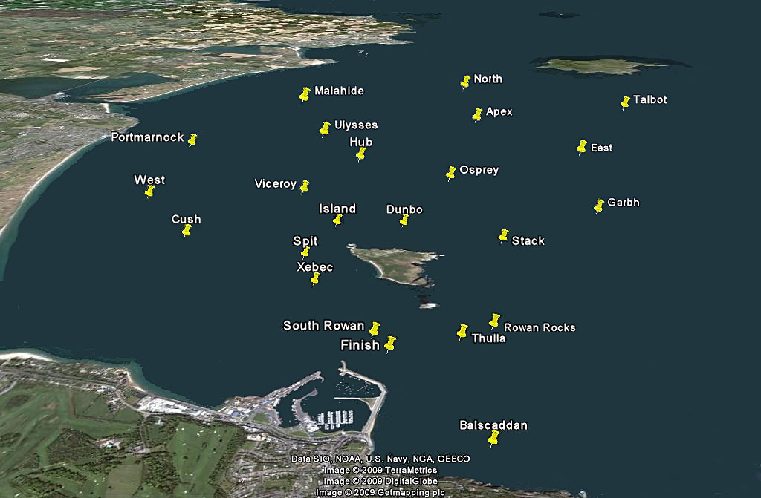

GENERAL

When entering/leaving Howth Harbour, stay on the right hand side of the fairway and harbour entrance i.e. always pass port to port. Also, Howth Sound is a restricted channel and accordingly boats shall not impede trawlers.

The attention of all participants is drawn to the car parking regulations in the vicinity of the Club. The Harbour Authority rigidly enforces these.

Competitors are granted temporary membership of Howth Yacht Club for the day of the racing; subject only to the provisions of the Club rules for withdrawing or withholding said membership.

