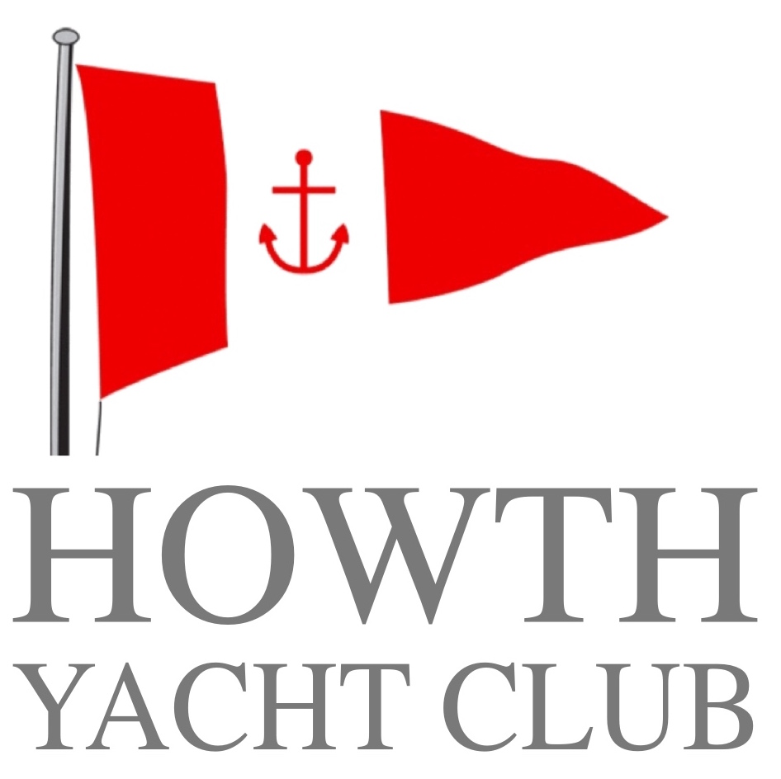

**Irish National Championships 2018**

**6th / 7th October 2018**

**NOTICE OF RACE**



 

[](http://www.google.ie/url?sa=i&rct=j&q=&esrc=s&source=images&cd=&cad=rja&uact=8&ved=0ahUKEwiRi7zlkdLWAhUlL8AKHSTICRgQjRwIBw&url=http://www.sail-world.com/112699/&psig=AOvVaw0w5MqCNbHDBnpiJxxpg5n1&ust=1507040562072197) 

**NOTICE OF RACE**

The organising authority is Howth Yacht Club and the Irish J109 Class Association.

1. **Rules**
   1. The event is governed by the Racing Rules of Sailing.
2. **Advertisin**g
   1. Boats may be required to display advertising chosen and supplied by the organizing authority.
3. **Eligibility and Entry**
   1. The regatta is open to J109 boats owned by members of the association. Boats normally kept outside of the island are deemed to be temporary members for this event.
   2. Late entries shall be at the discretion of the Committee.
4. **Entrance Fee**
   1. The entry fee for each boat is **€160.00**. Entries to be made online (www.riyc.ie) no later than ***Friday 5th October 2018.*** The entrance fee is non-refundable.
5. **Schedule**
   1. Registration may take place at Howth Yacht Club race office on Friday 5th October from 1730 to 2030 hrs. and Saturday 6th October from 0800 to 0930hrs.
   2. The schedule time of the warning signal for each race:-

***Saturday 6th October***  Race 1 warning signal 1025

Race 2 ASAP after Race 1

Race 3 ASAP after Race 2

***Sunday 7th October*** Race 4 warning signal 1025

Race 5 ASAP after Race 4

Race 6 ASAP after Race 5

No warning signal will be made after 1500hrs on Sunday 7th October

1. **Sailing Instructions**
   1. The sailing instructions will be available from the race office at Howth Yacht Club and the website www.hyc.ie
2. **Measurement**
   1. All participating boats shall, be members of the Irish J109 association.
   2. The boats will be raced under the prevailing J109 UK and Ireland Class Rules as published on [www.j109.org.uk/class-rules](http://www.j109.org.uk/class-rules) with the following amendments:-
      1. A maximum crew weight limit shall apply. A maximum crew weight regardless of the number of crew members shall not exceed 650 kg in swimming apparel excluding the Owner. Where a boat is jointly owned the ‘Owner’ shall be the person who is the largest or designated joint shareholder in the boat.
      2. No Cat 3 sailors are permitted. This is promoted as a Corinthian event.
      3. Delete rule 4.4.7 prohibiting Inhaulers and insert new rule 3.3.16 – Inhaulers may be fitted and used.
      4. Section 5.4 shall be deleted in its entirety and replaced with the following text:-

***5.4 Headsails, Furlers and Head foils***

Headsails may be manufactured of any woven or laminated materials. Headsails shall be attached to the forestay using hanks or the owners choice of standard commercially available furling head foil system (such as Harken, MK3, Racnor or similar) or non-furling head foil system (such as Tuff Luff or Harken Carbo Foil or similar) using #6 luff tape. The type and design of forestay foil is unspecified except that it cannot be an aero foil or wing type whose function is to add area to the headsail. UV protection tape may be applied to the leech and foot to cover the sail when furled. Windows are permitted.

Headsails may be furled or hoisted and dropped as per owner’s choice.

***5.4.1 Genoas will not be permitted***

***5.4.2 Jibs***

For jibs (i.e. sails with an LP of 4460mm 110% LP or less), up to four battens of any length are permitted on the leech. The definition of a batten is ‘Any material added to the sail, as a removable element, permanent stiffening, or other contrivance, the purpose of which is to support and or stiffen the sail’. There is no restriction on Luff Length provided the HSA does not exceed 40.60m2 when calculated with the IRC HAS formula.

***Note***

Limit of 3 headsails as outlined in 5.2 still applies.

1. **Race Area and Courses**
   1. The race area will be the East Coast of Ireland – Admiralty Chart 1468
   2. The courses to be sailed will be Windward / Leeward.
2. **Penalty system**
   1. Rules 44.1 and 44.2 shall apply
3. **Scoring**
   1. 3 races are required to be completed to constitute a championship
   2. Once 4 races have been completed, a boats series score will be the total of her race excluding her one worst score.
4. **Prizes**
   1. Prizes will be awarded to the first 3 places.
   2. Spot prizes may also be awarded.
5. **Disclaimer of Liability**
   1. Competitors participate in the regatta entirely at their own risk, See rule 4, Decision to Race. The organising authority will not accept any liability for material, damage or personal injury or death sustained in conjunction with, prior to, during or after the regatta.
6. **Insurance**
   1. Each participating boat shall be insured with valid third party liability insurance with a minimum cover of not less than three million EURO.
7. **Berthing**
   1. Berthing will be available at Howth Yacht Club marina for visiting yachts. Please contact the marina on 01 839 2777 for further details.
8. **Haul Out Restrictions**
   1. Boats shall not be hauled out after the time of the first prep gun race until the end of the regatta except with prior written permission of the Race Committee
9. **Social Programme**
   1. A social programme will be arranged by Howth Yacht Club and will be advised in due course.
10. **For Further Information** please contact

Irish J109 Class Captain Howth Yacht Club

Andrew Craig Caroline Gore-Grimes

086 8106210 Honorary Sailing Secretary

[andrew@andrewjcraig.com](mailto:andrew@andrewjcraig.com) honsailingsec@hyc.ie