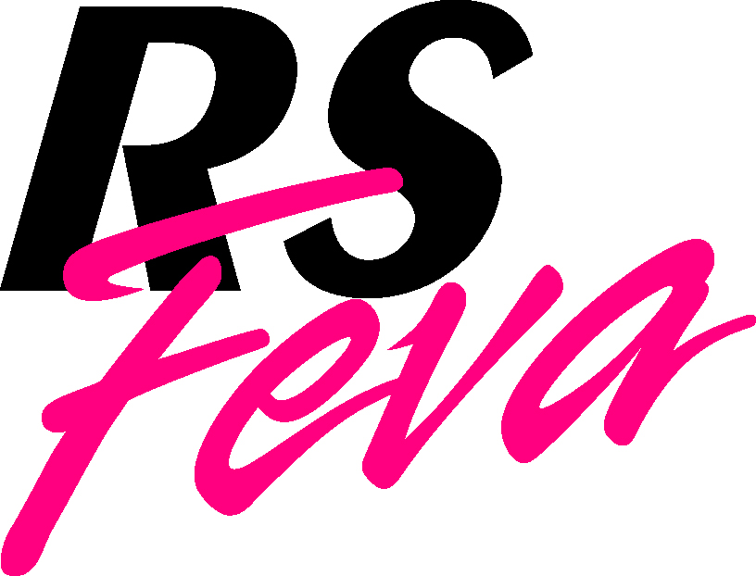

RS Feva National Championships 2018
Hosted by Howth Yacht Club

AMENDMENT 2 TO NOTICE OF RACE

CHANGE OF DATES

- The Championship will be held on Saturday, June 30th and Sunday, July 1st (no racing on Friday, June 29th).

- The contents of this Amendment change and supersede the published Notice of Race.

- Specific clauses from the published Notice of Race document are hereby revised and the amended wording is as shown hereafter. Revised text is highlighted in yellow.

3 FEES
3.1 The entry fee is €70 per boat for entries received prior to midnight on 24th June. Entries received after that shall be accepted at the discretion of the OA.

4 SCHEDULE
4.1 Registration: Friday, 29th June 6.30-8pm & Saturday, 30th June from 8.30-10.00am.
4.2 Briefing – A briefing for competitors will be held at 10.30am on Saturday, 30th June.
4.3 Eight races are scheduled. The schedule of races planned is:
Date Race
Saturday, 30th June Races 1 to 4
Sunday, 1st July Races 5 to 8
The Organising Authority reserves the right to sail one extra race per day, subject to an overall maximum of eight. ICF R displayed on the Finishing Vessel during the finish of a race shall indicate that another race is to be started that day.
4.4 The scheduled time of the first Warning Signal on Saturday, 30th June is 11.55am. The scheduled time of the first Warning Signal on Sunday, 1st July is 10.55am.
4.5 A minimum of three races is required to constitute an event.
4.6 A warning signal for a race shall not be made after 15.00 on Sunday, July 1st, except where it is preceded by a General Recall or Postponement Signal for the last race.

9 SCORING
9.1 When fewer than four races have been completed, a boat’s score will be the total of her race scores. When between 4 and 7 races are sailed a boat may discard the worst score from her total and when eight are sailed a boat may discard the two worst scores from her total. This changes RRS A2.

