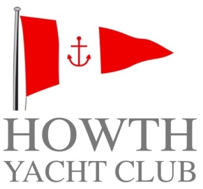

**Membership Application Form**

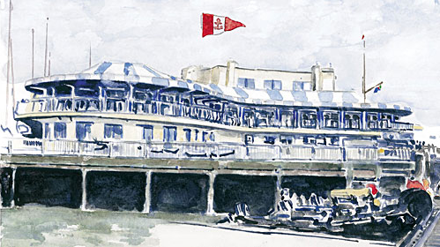

**SUBSCRIPTION RATES 2017**

**FAMILY €1100.00**

**ORDINARY (Over 32 years) €820.00**

**ORDINARY ((aged 30 & over 31) €525.00**

**ORDINARY (aged 28 & 29) €340.00**

**ORDINARY (aged 25 to 27) €175.00**

**ASSOCIATE €210.00**

**CADET (aged 19 to 24 inclusive) €125.00**

**COUNTRY €240.00**

**OVERSEAS €50.00**

**SENIOR €400.00**

**JUNIOR €105.00**

**2017 Introductory €300.00**

**(T&Cs apply)**

***For more information please contact***

***Howth Yacht Club***

***Middle Pier***

***Howth***

***Co Dublin***

***01 832 2141***

[***office@hyc.ie***](mailto:office@hyc.ie)

***Howth Yacht Club Membership 2017***

*Every candidate for Ordinary, Associate, Cadet or Country Membership must be 18 years of age and must be proposed and seconded by an Ordinary, Honorary or Senior Member, to both of whom he or she has been personally known for at least one year, and the candidate must also be known to, and recommended by, a member of the General Committee.*

*Completed application form, together with letter of recommendation from proposer, shall be sent to the Honorary Secretary. As Membership for the Club runs from January to December, your Membership is due for renewal at the start of the calendar year.*

***SENIOR*** *- is open to members who have 10 years continuous Ordinary membership and are aged 66 years or over.*

***ASSOCIATE*** *- is open to candidates who are spouses, widows or widowers of Honorary, Senior or Ordinary Members.*

***CADET*** *- is open to candidates 19 to 24 years of age inclusive.*

***JUNIOR*** *– is open to candidates 7 to 18 years of age inclusive.*

***COUNTRY*** *- is open to candidates who are resident outside a radius of 60 kilometres of Howth or who are voting members of any Yacht Club with which Howth Yacht Club has a reciprocal membership agreement.*

***FAMILY*** *- is made up of one Ordinary member, one Associate member and unlimited Junior members all from the same family.*

***2017 Introductory*** *– is limited to candidates who have not been an ordinary member since 31st December 2013.*

PAYMENT DETAILS

Please find enclosed Cheque Cash

IN THE AMOUNT OF €

Please debit my Amex / MasterCard / VISA / VISA DEBIT card, numbered

**EXPIRY CCV**

**Signature**

**Date**

For Office Use Only

**Have you previously been a member? If so, give details.**

**Address**

**Full Name**

**Please list members of your family who are HYC Members, if any.**

**Date of Birth**

**Occupation**

**Company**

**Please list other Yacht Clubs of which you are a Member, if any.**

**Mobile**

**Daytime No.**

**Email**

**Please give a brief history of your Sailing experience or and aspirations.**

Insert photo here

**DATE RECEIVED**

**Category applying for**

**DATE CLEARED FOR THE NOTICEBOARD**

**Date approved**

**MEMBERSHIP NUMBER / FAMILY ID / WEB ID**

**DATE OF ELECTION**

RECOMMENDED AND SIGNED BY

OF THE GENERAL COMMITTEE

**SIGNATURE**

**SIGNATURE**

SECONDER

**BLOCK CAPITALS**

SECONDER

PROPOSER

PROPOSER PLEASE ENCLOSE LETTER OF RECOMMENDATION

PROPOSER

**BLOCK CAPITALS**