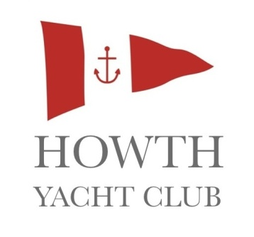
YOUTH KEELBOAT SAILING
Howth Yacht Club is offering its teenage members and their friends an opportunity to develop their sailing skills in a friendly, relaxed environment. Weather permitting, all training including briefings and theory will take place onboard the Club’s fleet of J80 keelboats.
If you have a group of friends who have already learnt to sail dinghies and would like to try some big boat sailing, why not get together and book a sailing course this Summer?
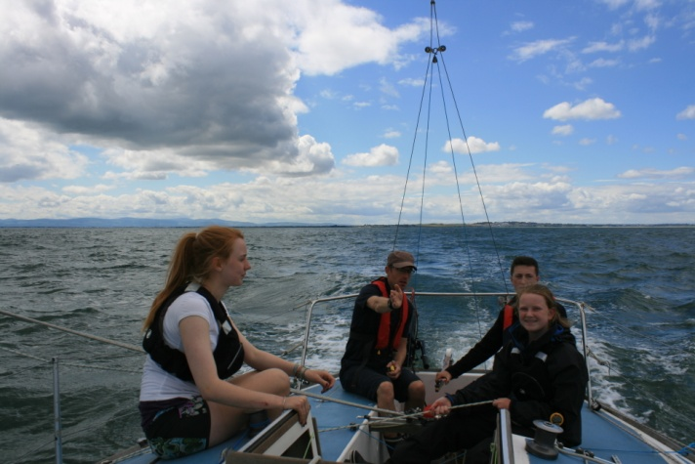
THE CHALLENGES
- Work together as a team of 3-5 sailors with an instructor.
- Confidently and safely carry out manoeuvres like picking up a mooring or a man overboard in a boat that weighs 1315 kgs and can carry up to 96m² of sails.
- Get involved in planning daily activities that cater for the interests of the crew on your boat.
- Develop the necessary skills that will enable you to make longer trips.

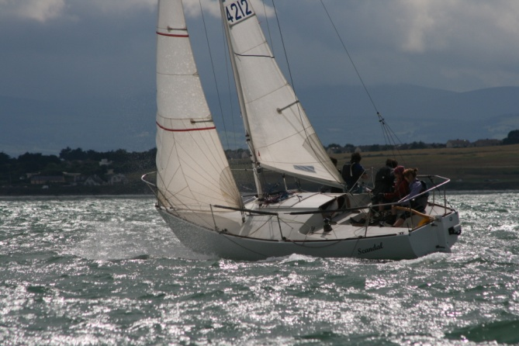
THE REWARDS
- Know how to safely plan and carry out a short sailing trip in the local area.
- Develop a range of boat handling skills that are useful for in sailing keelboats.
- ISA Keelboat Certificates up to Improving Skills level.
- Graduate on to our Adventure sailing programme.

