Howth Harbour facing crisis.

Dear (***INSERT NAME***),

Howth harbour as we know it was rebuilt 30 years ago to serve the fishing commercial and leisure users. It is now a major attraction for tourism and leisure as well as being the main commercial fishing port on the east coast.

The Harbour is facing a crisis due to the fact that it has been silting and no dredging nor maintenance has taken place in 30 years and therefore vessels are in danger of running aground at certain parts of the tide. This will impact on safety as well as tourism in the foreseeable future.
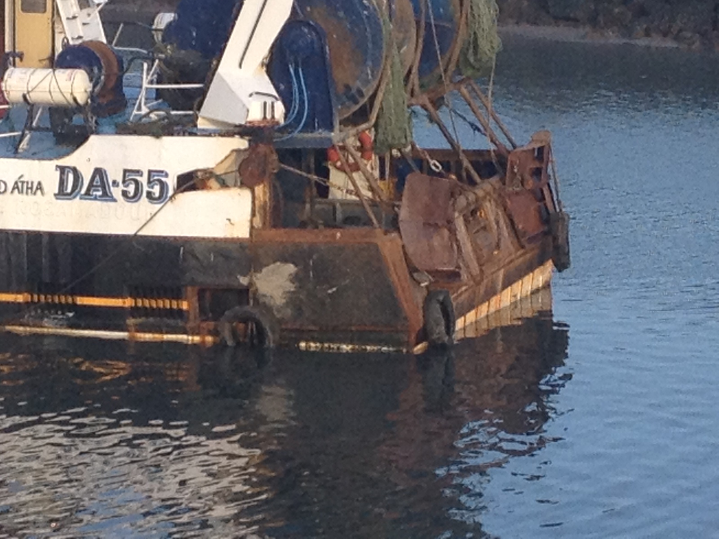
Unless immediate action is taken, more and more vessels will be unable to use the port and indeed it will impact on the provision of emergency services from the RNLI and the Coastguard.

It will take a minimum of one year to obtain the necessary license to dredge and will take another 12 months from the commencement of the project. With an average annual silt increase of 20mm there is no time to waste.

It is a scandal that we are celebrating 1916 and the harbour that hosted Asgard's arrival has been left neglected so much so that the boat would have difficulties berthing 100 years later, it would not be able to come alongside the harbour wall (as it did then) at almost all stages of the tide!

We need action now to support the viability of the East Coast's busiest fishing and leisure port.
As a public representative we would ask for your unequivocal and irrevocable commitment to save the harbour.
We would also ask you to contact the Minister for Agriculture and the Marine Mr Simon Coveney TD requesting him to immediately acknowledge his commitment to provide funding and to commence the work.

While some recent excellent infrastructural work has been done in the harbour and more being planned, these will be wasted and become irrelevant if vessels cannot access the port. The present government have provided funds to every other fishing port in the country in respect of dredging, but not Howth.

Howth Harbour needs to be dredged now.

Respect Howth's place in Irish history, past, present and future by ensuring that the harbour is dredged and can continue to serve the fishing, tourism and leisure industry.

Yours sincerely,

(***INSERT NAME***)

