sFor Sale
Westerly GK 24
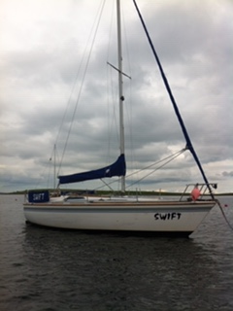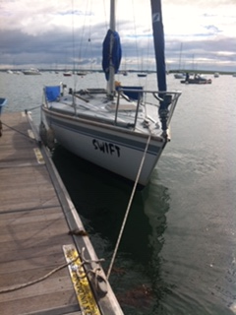
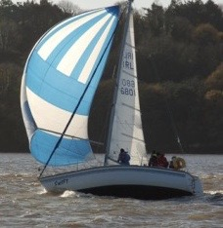

1981 Westerly GK 24 “Swift”
LoA 7.32m
Volvo Penta MD5A Diesel with twin blade folding propeller
Twin axle Road trailer

Details
Interior
2 Cabins 4 Berth 4’8”Headroom
Sink & double ring paraffin burner
Jabsco Marine Toilet
Electrical & Navigation Equipment
Single battery for cranking and domestic use
ICOM M401VHF Radio; DSC VHF aerial; Clipper Duet Log/Speed & Echo sounder; Navico Tillerpilot Autopilot; Compass; Barometer & Clock; Navigation Lights
Spars & Sails
Aluminium mast & Spars; 1 x 19 Stainless Steel standing rigging
Rope running rigging. Rotostay headsail furling. Alloy Spinnaker Pole
Watson Mainsail & Genoa; Aurn Genoa; Storm Jib; Spinnaker.
2016 Goacher Tri Laminate tri-radial Headsail & Luff Sock – UV strip added 2019.
Deck Equipment
Danforth anchor & chain; 2 x Lewmar single speed winches; 2 x Barbarossa (Harken) twin speed winched; Range of deck mounted cleats and clutches.
Safety Equipment
Bilge pump; Lifebuoy; Jackstays
Other Equipment
Boarding ladder; Dodgers & Sprayhood; Sailcover; Fenders.
Racing Record
Regularly and successfully raced in NHC2 class at SLYC against 32- 34 foot yachts. 2nd SLYC First Series 2019, 1st SLYC Second Series 2019. Wins at various Strangford Regattas.
Antifouling stripped 2016, hull treated with VC Tar prior to application of VC17.
This is a slippery yacht that can hold it’s own against larger yachts.
Lying ashore, Whiterock, Killinchy, Co Down.
£4250
Contact Stephen Clarke 07855 867167

