For Sale – Quickstep III – 820

Multiple Irish National and Multiple Championship winning Squib.
The fastest Parker in Ireland. Top 5 in every event, typically on the podium.
Irish Travellers Trophy winner three years running.

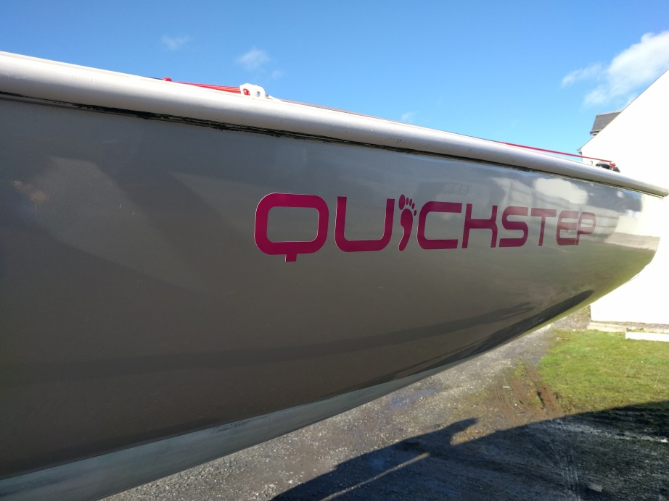 | 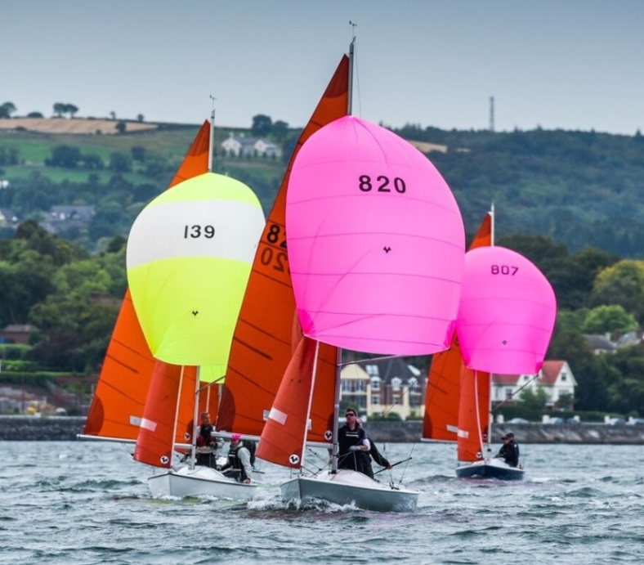

- Boat kept in immaculate condition.
- All shrouds, halyards, sheets, controls replaced and serviced regularly.
- Milanes Rudder
- Boat stored under cover/indoors every winter and when not in use
- Underside faired to 1500 grade. Super smooth.
- Topsides resprayed in 2013. Mercedes AMG silver.
- Superspar mast, new 2013.
- 2016 Racing suit of Batt Sails, used for events.
- Boat not sailed/raced since 2017, except for a brief period last year to compete in the Northerns in Howth. Which she won.
- Training/Club suit of Batt Sails also included.
- Road Trailer – Recently serviced.
- Flyaway spinny pole.
- Lightweight Cover
Ready to Race. Ready to Win.
This is a chance to buy a low-maintenance Parker Squib that can beat (and has beaten) any Squib in Ireland and Britain.
Price: £7,500
Contact: Gordon Patterson (+44 7971 488772) or Ross Nolan (+44 7557 525659)
gp@pattersonlifts.com rgnolan@gmail.com

