CÚILIONN: Beneteau First 30’
€12,500
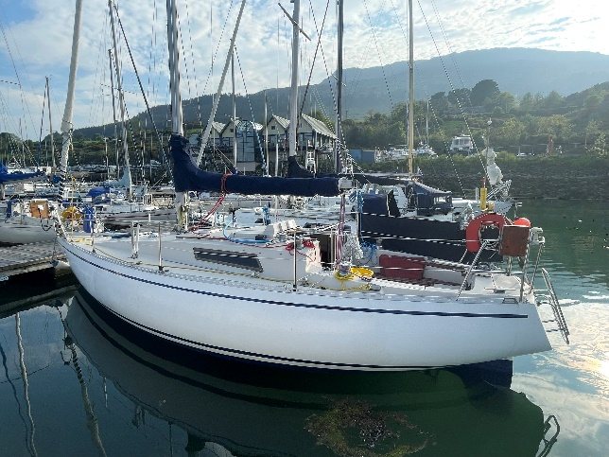

Type: Masthead Sloop; fin keel with rudder on skeg
Year of manufacture: 1980
Particulars - Length: 8.95m Beam: 9.38ft Draught: 1.70m
Construction: FG
Engine: Beta Marine 3 cylinder 20HP (2004)
Sails: Dacron Main (Watson Sails, 2023), Jib, Spinnaker with pole.
Accommodation: 8 Berths (will sleep 5 adults comfortably). Toilet cabin with single heads/washbasin. Galley area with twin hob, oven (gas). Chart table with Simrad VHF radio mounted and handheld. Potable water skin (83L)
Technical: 2 x 12 Volt Lead Acid Batteries; 12 volt Marine Rotary Isolating Switch; Batteries secured in leak-proof compartment in saloon; engine-driven alternator. Bulkhead mounted compass. Clipper Wind Instrument (NEW 2024). Clipper Speed and Depth gauge. Hardwood tiller (with extension). Spare tiller.
Ground Tackle: 10kg CQR anchor with chain in deck compartment; Grapnel anchor
‘Cúilionn’ is a cruiser/racer in great condition, ready to sail away. She has sailed Ireland’s eastern and southern coasts extensively in 2023 and 2024, always giving great responsive sailing. She comes absolutely ready to go, with a range of extra equipment including spare halyards, lines and sheets, and spare parts for the next engine service. She had some running rigging replaced in 2024, with brand new fenders and mooring lines a further addition. Can be viewed in Malahide Marina.
Contact:
charlesogdillon@gmail.com
Phone/WhatsApp: 083 066 9745

