J24 One Design Legal Alien Hull number: JRSP-2-87 4215 , Sail number GBR 4064

1987 Rogers boat in excellent condition and race ready. Up to date Marine surveyor report. Current ECHO & ICR certs.

Inventory included
Hull and keel
Road Trailer and trailer box with 1 spare wheels, straps
Mast, spreaders and rigging with spare rigging set
Rudder and tiller
Boom and mainsheet with kicker
Spinnaker Pole
Sheets and ropes and mooring lines
3 Genoas (1race)
2 Mainsails (1 race)
2 Jibs (1race)
2 Kites (1 race)
3.3hp Marina engine ( serviced 2021)
Race inventory as per rules
Veloctitek instruments
All certificates, lifting strop, rigging gauge,
Sail number IRL 4064 recently approved for Ireland.
Insured
€14K

Seller: Jill Sommerville 00353 862340359
Jillsommerville40@gmail.com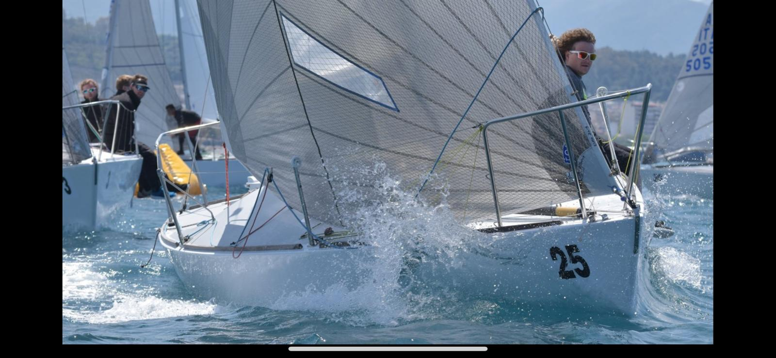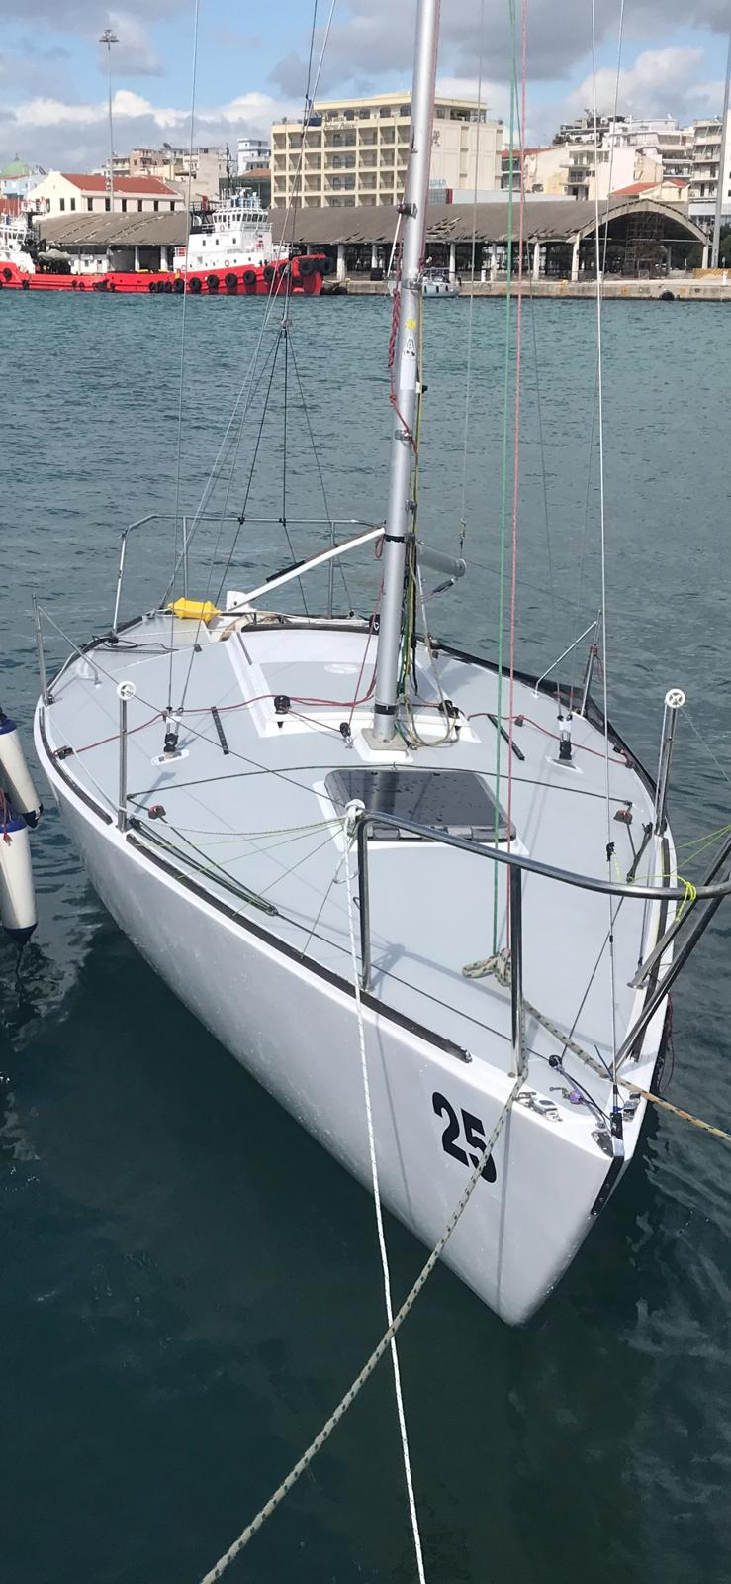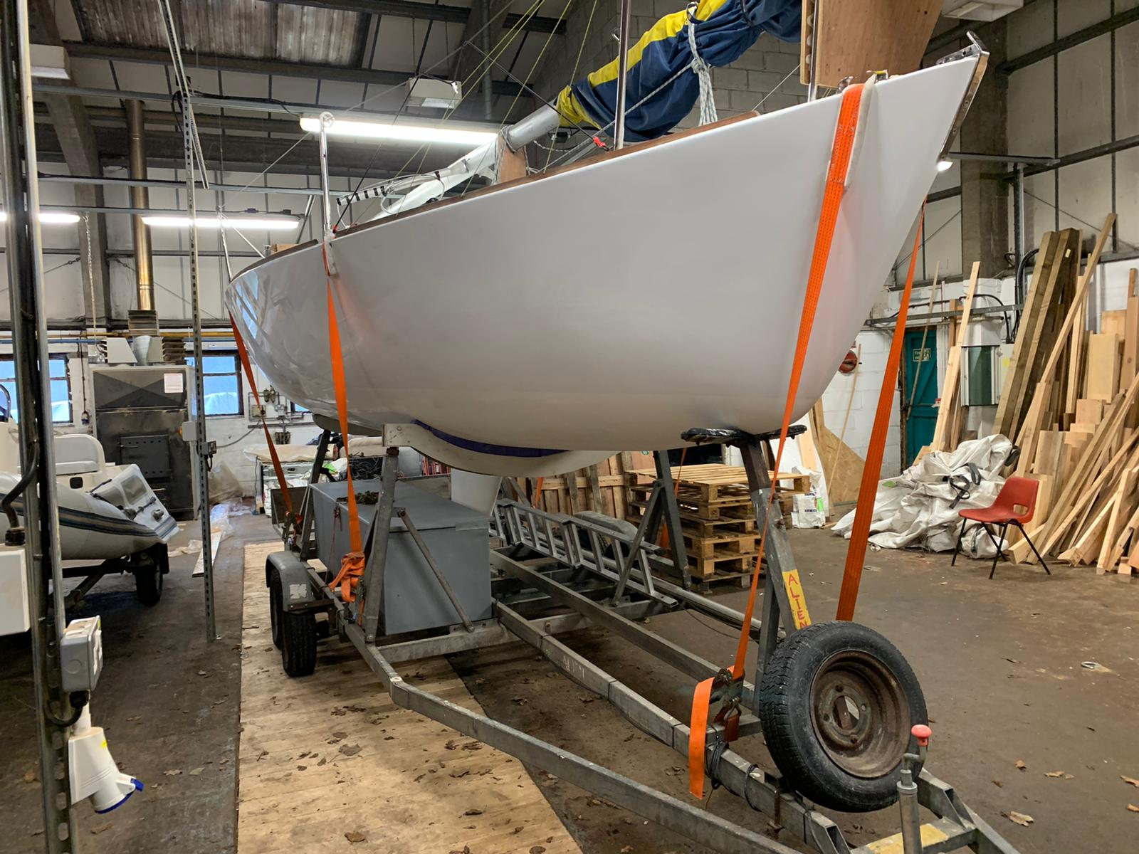

Photos at this link http://www.fotosail.com/events/2011j24euros/j24s_number/4064/

