Brief Description
X-302 Cruiser-racer for sale. This 30 ft (6 berth) yacht was built by X-Yachts of Denmark to a very high standard above and below decks. It has been carefully maintained and upgraded throughout her life. Good sail wardrobe for cruising or racing. Upgraded Yanmar engine. Sailed weekly throughout the year so all equipment is kept in top condition. Full specification available on request. Can be viewed on Howth YC marina by appointment.

When launched, the X-302 was described as:
‘The ultimate 30-foot Cruiser/ Racer - designed by Niels Jeppesen, X-Yachts of Denmark’.
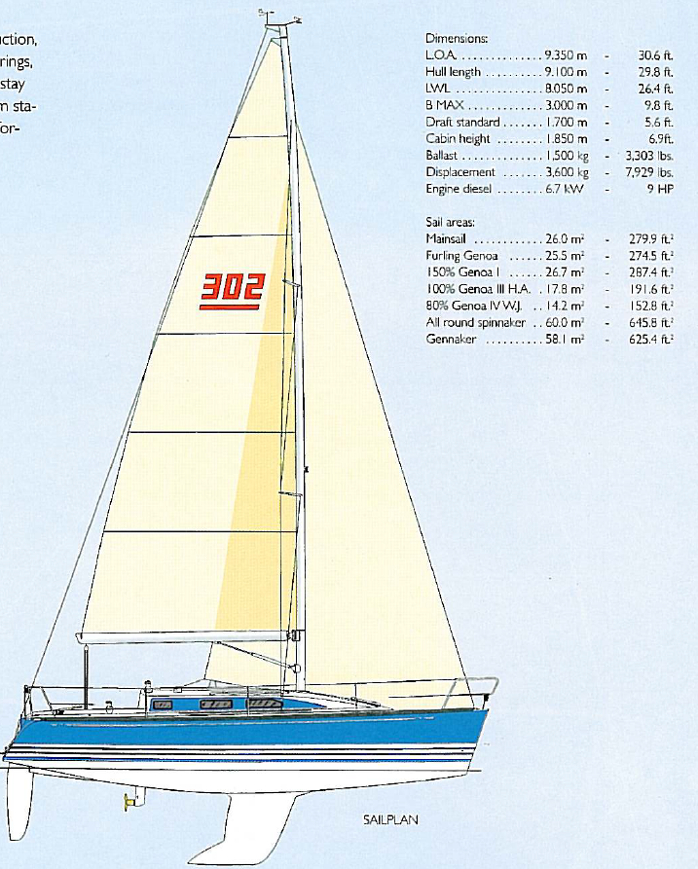
Nils Jeppesen talks about the X-302
Being a family man myself, I set out to design a 30-footer that would accommodate my own needs. To provide a safe fun yacht that could take two adults and four children sailing for a couple of weeks in comfort and at the same time have such a sailing performance that I could race her successfully at small or even big regattas. Such a boat should have plenty of storage space for all the essentials that accompany a family on holidays (toys, clothes, books, etc.) It must have good ventilation and comfortable sleeping and cooking arrangements.
However, such a boat must not suffer from a poor sailing performance, and among other things, must be able to carry a very tight forestay for good upwind performance. Above all, this 30-footer was to be a true X-Yacht, where quality and finish should be outstanding, and where sailing performance should be the very best, bringing maximum enjoyment for the crew; not only when racing in a regatta, but also when simply beating their friends’ 33-footer back to the marina! For the family cruiser, she offers a safe, comfortable “home from home”, and for the racing enthusiast it will be a delight to sail such a fast and stiff yacht.
Below Decks
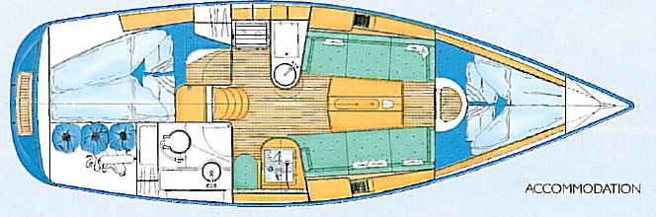
Wherever you look, you will find that there is ample space for storage of personal gear and equipment. Deep shelves below the deck and a hanging locker in the aft cabin with a practical wet locker for oilskins and boots in the head compartment, plenty of locker space in the roomy galley, provision for electronics and storage of books, etc. at the chart table and an enormous cockpit locker for the inflatable dinghy, fenders, mooring lines, etc. The interior has been designed with the cruising family in mind. Top grade Kaya mahogany has been used in conjunction with extensive use of laminated surrounds to produce an elegant, homely feel below decks. The absence of sharp corners in the interior is not only pleasing to the eye but also adds greatly to the safety and comfort of the yacht when at sea.
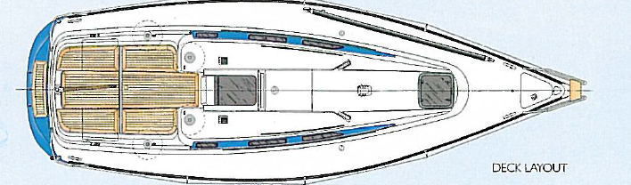
The key features which help make the X-302 a truly outstanding 30-footer include: sandwich hull and deck construction, steel bottom frame for keel and rig loads, tapered rudder shaft and low friction needle rudder bearings, powerful 15 HP Yanmar engine with sail-drive installation, wire rigging, extra-stiff mast section and forestay. Maximum sailing waterline length combined with maximum stability from the bulb keel and a very undistorted hull form. An extremely comfortable, high-volume interior finished with a GRP head liner and top-quality timberwork throughout.
X-302 MKII, Build No. 65

Freeboard / Anti Slip: | 9010 White
Waterlines / Sheerline / Deck House Side: | 5013 Kobolt Blue
Cushions: | 0510 Aron blue w. be.
Date of delivery ex Denmark: | 25/08/1999

Prestige Package:
Bottom treatment
Lewmar 30AST Ocean winch 2 sp. as genoa winches
Lewmar 30AST Ocean winch 2 sp. as halyard winches
Cooling compressor in cooling box
Suunto B115 compass, mounted.
Mainsail, 2 reefs, X-302
Genoa II, X-302
Boom-cover, blue, X-302

Further Extras:
X-302 Spinnaker equipment w/pole
Teak cockpit seats and sole
Cabinets/shelves in saloon
ST60 Tri-data log/depth

CONSTRUCTION
CE-CERTIFICATION

The X-302 MK 2 has been built in accordance with the European CE-Certification and meets the requirements of the CE-directive 94/25/CE for recreational crafts.
These rules require a certain minimum standard of hull and deck strength, structural bulkheads and stringer, keel and rudder and their attachment to the hull, safety and stability, engine installation, gas installation, sea cocks, manuals, and documentation of all major installations.

HULL/DECK
Hull and deck are built of hand laid fibre glass in sandwich construction with hard compressed Divinycell foam 15 -10 mm thickness.
Solid laminate in connection w. deck fittings, around keel bottom girder and rudder attachment, and by all through hull fittings.
Hull and deck are joint with special fibre glass glue and reinforced through the bolted alloy toe-rail for every 100 mm.
3 similar waterlines and sheer line at the white hull, window surrounding coloured as waterlines and white anti-slip area in deck - all colours/surfaces are moulded gelcoat.

RUDDER/STEERING
Rudder blade built in hand laid biaxial E-glass. Hard compressed PVC foam. Rudder stock in solid aluminium with diameter from 65 to 35 mm. Rudder head in anodised alloy and standard tiller in laminated curved teak.

KEEL
1,050 kg cast iron keel which provides a low weight centre and a high stability. The keel is fixed with 10 stainless steel bolts. The keel is treated against rust with 1 layer fibre glass and is filled with polyester filler and painted with light primer.

FLOOR/BOTTOM REINFORCEMENTS
Hot galvanized steel frame, glassed into the solid fibre glass part of the hull, taking the loads from all keel bolts and the mast-step. The steel frame is provided with an eye to take a central lifting strop.

STRUCTURAL BULKHEADS
All bulkheads are marine grade plywood varying from 9 - 16 mm and are glassed into the hull to stiffen the total structure.

MAST/RIGGING
The double spreader tapered mast is passing through deck and standing on the foremost floor frame. Inside tightening, Windex, Windex light, steaming light, and conduit for later el installation in mast head. Halyards in Spectra for mainsail and genoa. Boom with 2 reefs and boom outhaul - all led to cockpit halyard winches.
Discontinued 1 x 19 wire rig. 1:16 purchase block system for adjusting perm. backstay.
Deck layout prepared for below deck mounting of furling drum (option).

VANG
The vang unit is mechanical with a block system 1:8.

RAIL
Pulpit with teak step covering the recognized nav. lights. 2 push-pits with recognized stern light and flag holder. 6 stanchions with bases. Height of rail: 600 mm. Lifelines in 1 x 19 s/s cable with turnbuckles.

BLOCKS
5 blocks round mast ring, two 5 double halyard deck organizers on roof, 2 double blocks + rachet block with cam cleat on swivel arm for main sheet, 2 genoa sheet fairlead blocks on genoa tracks, 2 double blocks for mainsail car adjustment - and blocks and cam cleats for adjustable genoa sheet car under load.

OTHER DECK EQUIPMENT
5 winch stoppers, GF main sheet track with car. 2 GF genoa tracks, 2 black anodised toe-rails and 2 s/s toe-rail end fittings.
4 mooring cleats, 6 hinges with locking devices for the 2 aft lockers and the anchor locker.
Mast collar for blocks, ventilation grills at transom.
Stainless steel bow-fitting excl. bow roller, forestay shroud and perm. backstay chain plates.
Foldable s/s bathing ladder, water, and fuel filling-up caps.
Aluminium frame skylight on roof, 6 openable aluminium frame side windows. Plexi sliding hatch and 2 plexi washboards, lock system with key for upper washboard.

WINCHES/HANDLES
2 x Lewmar 30 A or similar for genoa sheet.
2 x Lewmar 16 A or similar for halyards.
2 x 10" single winch handles with lock.
ROPES/SHEETS/ANCHOR
Mainsheet: 18 m 10 mm Spectra
2 genoa sheets: 20 m 10 mm Spectra
2 moorings 15 m 10 mm Polyester
4 fenders with lanyards.
12 kg anchor with: 30 m lead inserted polyester anchor warp

BILGE PUMP
Hand operated bilge pump in cockpit sucking from the central integrated keel bilge. Electrical bilge pump with a manual switch.
ENGINE INSTALLATION
Standard engine is a 10 HP diesel S-drive engine with a 406 mm Gori folding propeller, rubber hung and insulated by means of sound absorbent material. Diesel inlet through extra water separation filter. 50 litres s/s fuel tank. Gear/gas control at helmsman in cockpit.

FRESH WATER INSTALLATION
120 litres PVC formed water tank with inspection cap, deck filling-up.
Pressure water system in galley and head.
(Hot water system, el pump for heads floor sump on request)

ELECTRICAL INSTALLATION
Two 70 amph batteries in fibre glass box.
El-panel at chart table with switches and indication diodes. 2 main switches. Throughout the yacht’s interior, adequate halogen spotlights. At nav. station - one halogen chart light. Nav. lights: red/green bow nav. light / white stern nav. light / steaming light at mast / Windex light at mast top.

INTERIOR
Dyed mahogany plywood with 3 layers of lacquer with light sanding in between, to obtain a silkmat surface

Main cabin
Two 190 cm longitudinal settees. Storage behind the settee backs. Freeboard lining with moulded mahogany plywood plates. Cabinets and shelves can be ordered as extras.

Galley
Large angular galley, gas cooker* with 2 jets and oven, 100 litres insulated cooling box (electrical and engine driven cooling plate on request), one s/s sink, water tap for pressure fresh water, amble space for crockery. Table tops in off-white Melamine.

Nav. Station
Nav. Table-top with amble space for charts and room underneath for folded charts. Lots of space for mounting of radio and navigation instruments. Freeboard lined with mahogany plywood plates.

Aft cabin
Separate aft cabin with large double berth 200 x 135 cm, wardrobe for hangers and shelves.
Freeboard lined with light grey imitation leather.

Head/Bathrooms
Spacious toilet with large basin surrounds, sink, and shower mixer taps. Self-bailing floor and outlet to keel's built-in bilge. Locker for toiletries. Large open wet locker for sailing clothes and the like.

Forepeak
The accommodation comprises double berth 230 x 140 cm and 2 freeboard shelves below deck. Freeboard lined with light grey imitation leather. 2 built-in wardrobes can be ordered as extras.

UPHOLSTERY
All cushions are of 30 kg/m³ foam with removable upholstery

OTHER EQUIPMENT
One 2 kg powder extinguisher as standard.
*3 kg gas bottle installed in separate self-bailing gas box, lowered aft of the port cockpit aft-locker hatch.

Right to changes without pre-notice reserved
X-YACHTS(GB)Ltd Saltmakers House Hamble Point Marina
School Lane Southampton SO31 4NB Tel: +44 (0)2380 453377
info@x-yachtsgb.com

Year built: 1999
CE norm: A
Hull material: GRP
Hull colour: white
Hull shape: round-bilged
Keel type: bulb keel
Superstructure material: GRP
Rubbing strake: stainless steel
Deck material: GRP
Deck finish: non-skid moulded in/ part-teak
Superstructure deck finish: non-skid moulded in
Cockpit deck finish: non-skid moulded in
Antifouling (year): 2022
Window frame: aluminium
Window material: perspex
Fuel tank (litre): 50 L. stainless steel
Level indicator (fuel tank): yes
Freshwater tank (litre): 120 L. polyethylene
Tiller steering + Tiller extension (Spinlock)

