HOWTH YACHT CLUB
Sutton Cross Pharmacy
Puppeteer 22 National Championships 2017

Howth Yacht Club, July 29th & 30th July

SAILING INSTRUCTIONS

1.0 Notice to Competitors
1.1 All notices will be posted on the Championship Notice Board located in the main archway beside the marina office.
2.0 Changes to Sailing Instructions or Schedule of Races
2.1 Any changes to the sailing instructions will be posted at least 2 hours before the start on the day it will take effect except where any change to the schedule of races will be posted by 2000 on the day before it will take effect.
3.0 Signals Made Ashore
3.1 Signals made ashore will be displayed on the flagpole at the top of the marina walkway and will be accompanied by the appropriate sound signals.
3.2 When flag AP is displayed ashore, ‘1 minute’ is replaced with ‘not less than 45 minutes’ in race signal AP.
4.0 Schedule of Races
Race No. Day First Warning Signal
1 Saturday 29^{h} July 11.00 hrs
2 Saturday 29th July As soon as possible after Race 1
3 Saturday 29th July As soon as possible after Race 2
4 Sunday 30th July 11.00 hrs
5 Sunday 30th July As soon as possible after Race 4
6 Sunday 30th July As soon as possible after Race 5

If in the opinion of the Race Committee, it is deemed prudent to hold race four immediately after race three on Saturday 29th July, code flag flag Q will be displayed at the finish of race 3.
This decision shall be solely at the discretion of the Race Committee.

5.0 Courses
Courses will be Windward/Leeward style courses, laid approx. as shown in the diagram in the attached appendix and with marks rounded in the sequence listed on the diagrams.
The Class Flag for the Puppeteer Class is Flag A.
6.0 Shortening Courses
The course may be shortened at marks 1 or 3 in accordance with RRS Race Signals “S”.
Should the Race Committee wish to shorten a race to finish upwind at the start/finish line (the boats having finished one round), code flag “V” will be displayed from a Rib to leeward of Mark 3 accompanied by repeated sound signals. This changes RRS Race Signals.
7.0 Marks
7.1 Marks 1,2, and 3 will be black inflatables. The Start Mark will be an orange cylindrical mark and the Finish Mark will be a red/orange spherical mark.
8.0 The Start
8.1 The start line shall be between the Red and White striped pole or the main mast on the committee boat and an orange inflatable mark, which shall be left to Port.
8.2 Races will be started in accordance with RRS 26.
8.3 A boat that has not started 10 minutes after her starting signal will be scored DNS - This changes RRS 35, A4 and A5.
9.0 Change of Position of the Next Mark
9.1 The Race Committee may change the position of any mark to maintain the course configuration. The change will be made before the leading boat has begun the leg. For major changes only the change may be signalled as per RRS 33 using RED/GREEN flags or boards and or (+) / (-) as appropriate
9.2 Minor changes to the course ( +/ – 10 degrees, or +/- 100 metres) will not be signaled.
10.0 The Finish
10.1 The finish line, unless shortened, will be between the Red and White pole, or main mast on the finishing vessel displaying a Blue flag and a small round Orange/Red buoy. Note: the starting mark for the next race may be in position during the finish
11.0 Time Limits
11.1 The time limit for each race shall be 2 hours:
11.2 Boats failing to finish within 20 minutes after the first boat finishes will be scored DNF. This changes RRS 35, A4 and A5

12.0 Protests and Requests for Redress
12.1 Protests shall be written on an official Irish Sailing Protest Form and lodged with the Protest Convenor (or placed in the protest box) located in the Race Office. A limited number of protest forms may be available in the Race Office, however Protest forms are available to download from HYC website.
12.2 The Protest time limit shall be 1 hour after the last boat finishes racing each day and shall be posted on the main Championship Notice Board.
12.3 The Schedule of Protests Hearings shall be posted on the Championship Notice Board and will be 10 Minutes after the expiry time of the Protest Time Limit.
12.4 Any boat intending to seek Redress or Protest another yacht in a Race shall display a Red Flag in accordance with Rule 61.1(a) and shall notify the Finishing Vessel of her intention to do so and seek acknowledgement from the Race Officials.
13.0 Scoring System
13.1 The series will be scored as provided in Appendix A of the RRS using the Low Point Scoring System.
If four or more races are completed, one discard will be allowed.
14.0 Communication to Competitors whilst afloat
14.1 It is strongly recommended that all boats carry a VHF radio.
14.2 The Race Committee may issue communications to Competitors by VHF Radio on Channel 77.
15.0 General Comments
15.1 The turnaround time after each race will be as short as possible.
APPENDIX
All courses will be windward/leeward style courses and laid approx. as shown in the diagram below.
Course (unless other wise shortened)
Start - 1 – 2 – 3 – 1 – 2 – 3 – Finish
All marks shall be rounded to port.
Course “W” Windward/Leeward:
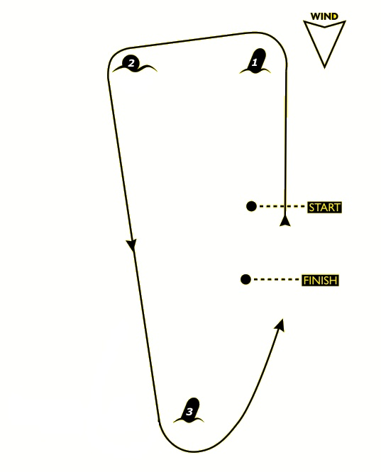

Course “T” Triangle

