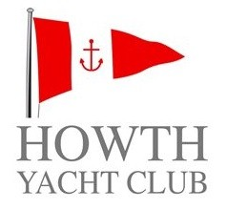
In association with
Irish University Sailing Association
IUSA Student Yachting Nationals 2017 incorporating the SYWoC Qualifiers for 2017.
Date: 29th – 30th April 2017
Changes to Sailing Instructions
CHANGE 1
Specifying Sunday
5. Schedule of Races
5.4 The Warning Signal of a race will be not be given after 1600 on Sunday

CHANGE 2
Correction of SI reference
13. Penalty System
13.1 RRS 44.1 is changed so that the Two-turn Penalty is replaced by a One-turn Penalty, except when SI 13.3(a) iii applies

Scorie Walls, PRO
Friday 28th April 2017, 2115

