 | Howth Yacht Club  Laser End of Season Team Challenge and Round the Island Race 2017  Saturday 11th March 2017  Organised by Howth Yacht Club | 

SAILING INSTRUCTIONS

1. Rules
Racing shall be governed by the Racing Rules of Sailing (RRS), the prescriptions of the Irish Sailing Association and the rules of the Laser Class, except as amended by these Sailing Instructions. Advertising in compliance with ISAF Regulation 20 is permitted.
.

2. Notice to Competitors
Notice to competitors will be posted on the official notice board located in the archway beside the Marina Office.
A Briefing will take place outside the Marina Office at 9.45.

3. Changes to Sailing Instructions
Any change to these Sailing Instructions will be issued by the Race Committee in writing.
Changes will be posted on the Official Notice Board not later than one hour before the scheduled start of the first race affected. The Notice Board is beside the walkway from the pedestrian entrance gate to the boat deck area

4. Signals Made Ashore
Signals made ashore will be displayed on the flagpole at the top of the Marina Bridge.
When flag ‘AP’ is displayed ashore ‘one minute’ is replaced with ‘not less than 30 minutes’.
Flag ‘L’ with one sound signal indicates an amendment to the Sailing Instructions has been posted.

5. Schedule of Races
If conditions permit, a preliminary race sailed on a Windward Leeward course may precede the Round the Island Race. Numeral 1 displayed on the Committee Boat will indicate that this race will be sailed. The results from this race will count towards the team prize for the Round the Island Race.
If conditions warrant it, the Race Committee may set a Windward Leeward course instead of the Round the Island race. Flag W displayed on the Committee Boat at the time of the Warning Signal for the Round the Island race indicates that a Windward Leeward course is to be sailed. Where a preliminary race is sailed, the Round the Island race starting sequence will be signalled as soon as is possible after the conclusion of that race.

First Warning Signal: 11.00
Start signal for Laser (all rigs): 11.05

6. Class Flags
The Class flags will be as follows:

Laser Standard, Radial & 4.7: Laser Class Flag (All rigs will start together)

7. Racing Area
The racing area will be north of Howth Harbour with the starting lines laid in Howth Sound.

8. The Courses
A Windward/Leeward course will have an offset mark (mark 2) close to the Windward mark. All marks will be left to port.

Lasers – Full Rig and Radials Start - 1 - 2 - 3 - 1 - 2 - 3 - 1 - 2 - 3 – Finish (3 laps)
4.7 rig Start - 1 - 2 - 3 - 1 - 2 - 3– Finish (2 laps)

Note: Marks 1 and 3 designate the Windward and Leeward marks in the sequence of rounding.

It is not necessary to pass through the Finishing line at the end of each round.

In addition to the conventional ‘shorten course’ procedure at a mark of the course, the course may also be shortened by requiring boats to sail directly from a mark to the finishing line. As boats round a mark, ICF ‘F’ may be displayed from a nearby RIB, accompanied by repeated short sound signals. Boats shall then sail directly from that mark to the Start / Finish line and finish from the direction of the last mark. This changes Rule 32.2. If ICF ‘F’ is displayed from a RIB in the vicinity of marks 1 and 2, the flag shall be deemed to be displayed beside mark 2.

The Race Officer may reposition marks during a race to keep the course true to the wind. This will not be signalled. This changes RRS 33.

For the Round the Island race (unless flag W is displayed), the course will consist of a leg to a windward mark, around a spreader mark, both left to port, and then downwind to a Turning Mark.

The required side for rounding the Turning Mark for the first time will be advised by hoisting a red or green flag prior to the Warning Signal for the race (diagram attached shows Port rounding on the way to the Island but may be starboard depending on flag hoisted). Boats will proceed to round Ireland’s Eye in a direction of their choice and the Turning Mark shall be left to port before boats sail to the Finish line.

The sequence of mark roundings forming the course for the Round-the-Island Race (unless it is being sailed on a Windward Leeward course) is shown on the appendix. A Hazard Mark (H) may be positioned south of the southern tip of Ireland’s Eye. Boats MUST pass to the SOUTH of this mark between their first and second rounding of the Turning mark (see SI 9) and shall not pass between the Hazard Mark and the Island. Where the Hazard Mark is being used, a Yellow flag shall be displayed on the Committee Boat prior to the Warning Signal for the Round the Island race.

9. Marks
The outer end of the Start Line will be a black spherical mark.
The Finish Mark will be a yellow spherical mark.
Marks 1 and 2 will be an orange spherical.

For a Windward Leeward race, mark 3 will also be an orange spherical but for the Round the Island race it shall be described as the Turning mark and will be an Orange Inflatable Pillar mark.

The Hazard Mark off the southern tip of Ireland’s Eye, if used, will be a YELLOW INFLATABLE mark.

10. The Start
The starting procedure will be in accordance with Rule 26 (5 – 4 – 1 – GO). The start line will be between the flagpole on the Committee Boat and a black spherical outer limit mark.

11. The Finish
The finishing line will be between the flagpole on the Committee Boat and a yellow spherical outer limit mark.

12. Time Limit
The time limit for the leading boat in each fleet shall be 90 minutes for the Round the Island race and 60 minutes for a W/L race. Rule 35 is amended so that any yacht that fails to finish within 30 minutes of the first boat of its Class to sail the Round the Island course and finish will be deemed to have retired. For a race using a W/L course, the corresponding limit shall be 15 minutes.
After the leading boats have finished a race, the Race Committee may offer finishing positions to boats which have not yet finished, starting at the back of the fleet. This changes Rules A4 and A5.

13. Protests
Protests must be made on an official ISA form (available from the Race Office) and lodged within 45 minutes of the last boat crossing the finishing line for the last race sailed.

14. Scoring System
The scoring system will be as per the low Point Scoring System (Appendix A) as follows:
1st = 1 point, 2nd = 2 points, 3rd = 3 points, etc., but points for those falling into the following categories shall be awarded as stated:

DNC scores points equal to the number of entries.
DNS / OCS / DNF / RET/RAF scores points equal to the number of starters in the race.
DSQ scores points equal to the number of entries in the event plus four.

15. Competition and Prizes
Class results for the Round the Island Race shall be provided for each Laser rig size (Full, Radial and 4.7) where there are more than three boats with the particular rig size registered to race on the day.

The Skehan Trophy will be awarded to the winner of the Laser Standard Rig Class in the Round the Island race. A prize will be awarded to the winner of the Laser Radial Class and, provided there are at least three entries, a prize will be awarded to the winner of the Laser 4.7 Class.

The overall Club Challenge trophy will be awarded to the winning team. Teams of three boats will be selected at Registration and will be displayed on the Official Notice Board not later than 45 minutes before the Warning Signal. Team results will be calculated by adding the scores of each member of the team in all races sailed. In the event of a tie on points between teams, the tie shall be broken in favour of the team with the lowest aggregated points score in the last race and, if still tied, the team with the best result by a team member in the last race shall be the winner.

In calculating a team’s total score, where the team is composed of sailors using different rig sizes, the points for each team member shall be calculated by taking their overall fleet position in each race sailed, regardless of rig size.

16. Club Membership
All visiting competitors are granted temporary membership of Howth Yacht Club.

17. Sign out / sign in
For safety reasons, all helms are required to sign out before going afloat and to sign in when coming ashore after racing or having retired. The form will be held in the race office beside the marina office. Failure to do so will incur a penalty, without a protest hearing, equivalent to DNF for the race, or races, for which the boat failed to comply with this instruction. This changes rule 63.1 and Appendix A5.

Safety & Additional Information

Safety

Competitors are reminded of RRS Fundamental Rule 4 'Decision to Race', which reads ‘A boat is solely responsible for deciding whether or not to start or to continue racing’. In reaching a decision, the competitor should bear in mind the fact that the series is a winter event in which wind chill, water temperature and weather conditions can quickly induce fatigue. Personal buoyancy shall be worn at all times. Wet suits shall not be recognised as personal buoyancy. Suitable protective clothing shall be worn at all times.

The Race Committee recommends the following minimum:
3.5 mm long john wetsuit, long sleeve jumper, wind-proof suit, wet suit boots, hat or balaclava or, as an alternative, a dry suit, tee shirt, long sleeve jumper, warm trousers, wet suit boots, hat or balaclava.

All boats shall have a painter, with minimum diameter of 6 mm and at least 3 metres in length, made fast to the bow.

Competitors are advised to regularly cheek their equipment for possible defects, e.g. loose rivets, frayed ropes, insecure bung, loose tiller extension universal joint, split rings, etc.

Competitors shall co-operate with Safety Boat crews and should accept their advice.

In adverse weather conditions competitors are reminded of the possibility of coming ashore on Claremont beach.

Outside assistance

Boats receiving assistance from official safety boats shall be not be obliged to retire from the race. This changes RRS 41. However, where a Safety Boat crew are of the opinion that any boat is committing the resource for an unacceptably long period and advise the sailor to retire, the boat shall be obliged to immediately retire from the race being sailed when the advice is provided.

Rules of the Road at Sea

When leaving or entering the Marina area and harbour entrance boats shall keep in single file on the right hand side of the channel, passing vessels going the other way ‘port side to port side’. Trawlers have right of way due to restricted waters in the area from the entrance of the trawler dock out to the Rowan Rocks buoy.

Sail Numbers

Sails shall have the correct sail number clearly displayed on both sides in accordance with Class Rules. Permission from the results office shall be requested in writing before going afloat should a competitor wish to sail under a different number from that under which he / she is entered.

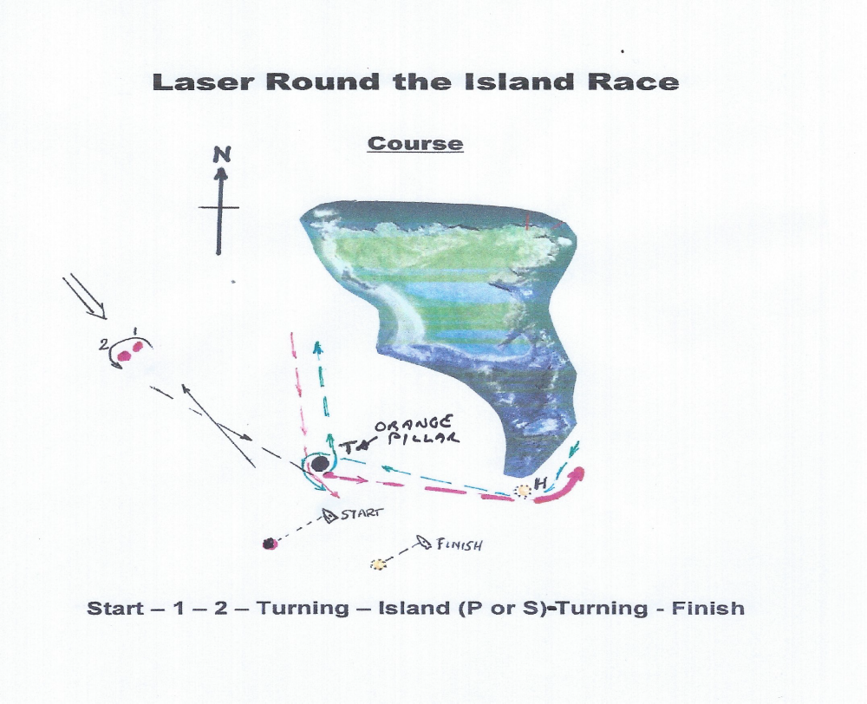
Note:

- The above course details will apply where the fleet races around Ireland’s Eye and is indicative only – north westerly wind direction used in example. The course orientation and positioning will vary depending on the wind direction.

- After rounding marks 1 and 2 and leaving them to port, boats shall round Turning Mark (T) before proceeding to round the Island.

- Committee Boat will display a red flag if Turning Mark (T) is to be left to port by boats on their way to the Island or will display a green flag if T is to be left to starboard.

- After rounding the Island, T shall be left to port by all boats before sailing to the Finish.

- Boats may not pass between mark H (if laid) and the Island.

