Howth Yacht Club
OPEN LASER FROSTBITES SERIES
2016 / 2017
Organised by Howth Yacht Club

SAILING INSTRUCTIONS

1. Rules
Racing shall be governed by the Racing Rules of Sailing (RRS)*, the prescriptions of the Irish Sailing Association and the rules of the Laser class, except as amended by these sailing instructions. Advertising in compliance with ISAF Regulation 20 is permitted.
Note: The Racing Rules of Sailing 2017-2020 will come into effect on 1st Jan. 2017 and are available on the World Sailing website: www.sailing.org.
.
2. Notice to Competitors
Notice to competitors will be posted on the official notice board located in the archway beside the Marina Office.

3. Changes to Sailing Instructions
Any change to these sailing instructions will be issued by the Race Committee in writing and shall apply to races subsequent to the time of their issue. Changes will be posted on the official notice board not later than two hours before the scheduled start of the first race affected. In the event of the number of races sailed falling behind schedule due to adverse weather, etc., the Race Committee reserve the right to run up to 3 races per day to redress the shortfall. Where this is intended, in addition to Changes to Sailing Instructions posted on the official notice board, an emailed notice will be circulated to those competitors who have provided an email address no later than Friday midnight prior to the day it is planned to hold an additional race. The issue of such an email will be deemed to have provided adequate notice of the Race Committee's intentions.

4. Signals Made Ashore
Signals made ashore will be displayed on the flagpole at the top of the Marina Bridge.
When flag “AP” over the Laser flag is displayed ashore ‘one minute’ is replaced with ‘not less than 30 minutes’.
Flag “L” over the Laser flag with one sound signal indicates an amendment to the Sailing Instructions has been posted. This signal will only be made on the first day of racing after each amendment has been posted.

5. Schedule of Races
It is intended to sail two races each day (back-to-back), with the exception of New Year’s Day and the End of Season ‘Round the Island’ Race.

Racing is scheduled as follows:

Series 1: Sundays 6th November – 18th December 2016  (14 races) | 1st Warning Signal 1045
New Year’s Day Race: 1st January 2017 | Warning Signal 1155
Series 2; Sundays: 8th January – 5th March 2017 (18 races) | 1st Warning Signal 1030
End of Season ‘Round the Island’ Race: Saturday 11th March 2017 | Warning Signal 1055

6. Class Flags
The Class flags and order of starts, where Classes are not starting together, will be as follows:

Laser Standard: Laser Class Flag
Laser Radial: Flag ‘R’
Laser 4.7 Flag ‘J’

The Class flags displayed at the Warning Signal will show the Class to start next. The Race Committee have the discretion to combine classes to start together as they see fit and the Class flag(s) displayed at a warning signal will indicate the next Class(es) to start.

7. Racing Area
The racing area, except for the Round the Island race, will be north of Howth Harbour and west of Ireland’s Eye.

8. The Courses
The course to be sailed will be indicated by displaying the appropriate course flag on the committee boat. All marks will be left to port.

Course Flag ‘O’ Olympic triangle
Course Flag ‘W’ Windward / Leeward

Course Diagrams – Refer to Appendix A

Olympic – Standard & Radial Rigs Start - 1 - 2 - 3 - 1 - 3 - 1 - 2 - 3 – Finish
4.7 Rigs Start - 1 - 2 - 3 - 1 - 3 – Finish

W/L - Standard & Radial Rigs Start - 1 - 2 - 3 - 1 - 2 - 3 - 1 - 2 - 3 – Finish
4.7 Rigs Start - 1 - 2 - 3 - 1 - 2 - 3– Finish

It is not necessary to pass through the Finishing line at the end of each round.

In addition to the conventional ‘shorten course’ procedure at a mark of the course, the course may also be shortened by requiring boats to sail directly from a mark to the finishing line. As boats round a mark, flag ‘F’ may be displayed from a nearby Rib, accompanied by repeated short sound signals. Boats shall then sail directly from that mark to the Start / Finish line and finish from the direction of the last mark. This changes RRS 32.2. Where a W/L course is in use and the Rib is in the vicinity of marks 1 and 2, the flag shall be deemed to be flown beside mark 2.

The Race Officer may reposition marks during a race to keep the course true to the wind. This will not be signalled. This changes RRS 33.

9. Marks
The outer end of the Start Line will be a BLACK SPHERICAL mark.
The Finish Mark for both races will be a YELLOW SPHERICAL mark.
The Start Mark for the second race (BLACK SPHERICAL) may remain in place during the finish of the first race. All other marks will be RED SPHERICAL.

10. The Start
The starting procedure will be in accordance with RRS 26 (5 – 4 – 1 – GO). The start line will be between the flagpole on the committee boat and a BLACK SPHERICAL mark. Boats whose warning signal has not been made shall avoid the starting area.

11. The Finish
The finishing line will be between the flagpole on the committee boat and a round YELLOW mark.

12. Time Limit
The time limit for the leading yacht in each fleet shall be 60 minutes. RRS 35 is changed as follows: "any yacht that fails to finish within 15 minutes of the leading yacht in its class shall be deemed to have retired" and such boats shall be scored as DNF. This changes Appendix A5.

After the first boat has finished, the Race Officer may offer a finishing position to the boat still racing in last place. The finishing position offered to a boat will be the number of boats ahead of it (both finished and still racing) plus 1. A boat is not obliged to accept such an offer unless it is the last boat still racing. The Race Officer is not obliged to make such an offer. A boat that accepts the place offered will immediately cease to race, and the Race Officer may repeat this process with the next boat. The offer may be made via rescue or support boat personnel. This changes the definition of the word "Finish"." This changes RRS 35 and A4.

13. Protests
Protests must be made on an official ISA form (available from the HYC Bar) and left in the Protest Box in the Clubhouse within 24 hours of the finish of the race concerned. Protests will be heard at a time that will be notified to all parties involved.

14. Scoring System
The scoring system will be as per the low Point Scoring System (Appendix A) as follows:
lst = 1 point, 2nd = 2 points, 3rd = 3 points, etc., but points for those falling into the following categories shall be awarded as stated:

DNC scores points equal to the number of entries for the series.
DNS / OCS / DNF / RET/RAF scores points equal to the number of starters in the particular race.
DSQ scores points equal to the number of starters plus four.

Discards: One discard is allowed for every complete multiple of four races sailed.

In the event of a tie in a series, Appendix A2.3 shall apply. Points are accumulated by the helmsman not the boat.

Persons not properly entered in the series shall not compete. Boats participating in the series shall only be raced by helmsmen who have been properly entered. Single race entrants shall not score points in the series.

15. Club Membership
All competitors are granted temporary membership of Howth Yacht Club on racing days.

Persons not properly entered in the series shall not compete. Boats participating in the series shall only be raced by helmsmen who have been properly entered. Single race entrants shall not score points in the series.

15. Club Membership
All competitors are granted temporary membership of Howth Yacht Club on racing days.

16. Sign out / sign in
For safety reasons, all helms are required to sign out before going afloat and to sign in when coming ashore after racing or having retired. The form will be held in the race office beside the marina office. Failure to do so will incur a penalty, without a protest hearing, equivalent to DNF for the race, or races, for which the boat failed to comply with this instruction. This changes RRS 63.1 and Appendix A5.

Safety & Additional Information

Safety
Competitors are reminded of RRS Fundamental Rule 4 'Decision to Race', which reads "A boat is solely responsible for deciding whether or not to start or to continue racing".

In reaching a decision, the competitor should bear in mind the fact that the series is a winter event in which wind chill, water temperature and weather conditions can quickly induce fatigue. Personal buoyancy shall be worn at all times. Wet suits shall not be recognised as personal buoyancy. Suitable protective clothing shall be worn at all times.

The Race Committee recommends the following minimum:
3.5 m.m. long john wetsuit, long sleeve jumper, wind-proof suit, wet suit boots, hat or balaclava, or as an alternative a dry suit, tee shirt, long sleeve jumper, warm trousers, wet suit boots, hat or balaclava.

All boats shall have a painter, with minimum diameter of 6 mm and at least 3 metres in length, made fast to the bow.

Competitors are advised to regularly cheek their equipment for possible defects, e.g. loose rivets, frayed ropes, insecure bung, loose tiller extension universal joint, split rings, etc.

Competitors shall co-operate with the rescue crew and should accept their advice.

In adverse weather conditions competitors are reminded of the possibility of coming ashore on Claremont beach.

Rules of the Road at Sea
When leaving or entering the Marina area and harbour entrance please keep in single file on the right hand side of the channel passing vessels going the other way on your port side. Trawlers have right of way due to restricted waters in the area from the entrance of the trawler dock out to the Rowan Rocks buoy.

Dinghy Park
All Lasers must display a 2016/2017 HYC sticker on the transom. Masts must be stored with the sections separated. Road trailers are not permitted in the Dinghy Park other than for loading / unloading. All Lasers must be removed from the Dinghy Park not later than Monday 13th^{th} March 2017. Any boats not removed on time, or trailers left in the Dinghy Park, may be placed outside the Club Premises and left at the owner’s risk.

Trolleys:
To speed up the recovery of boats when returning from sailing you are asked to take the first available trolley. It is a condition of entry that each boat has its own serviceable trolley. Sailors’ own trolleys can be recovered on the last day of each series. Owners are responsible for identifying their own trolleys.

Sail Numbers
Sails shall have the correct sail number clearly displayed on both sides in accordance with Class Rules. Permission from the results office shall be requested in writing before each day’s racing should a competitor wish to sail under a different number from that under which he / she is entered.

Appendix A - Courses
Olympic – Course flag ‘O’  Full and Radial Rigs (as per diagram)  Start - 1 - 2 - 3 - 1 - 3 – 1 - 2 – 3 – Finish  4.7 Rig  Start - 1 - 2 - 3 - 1 – 3 – Finish |  | 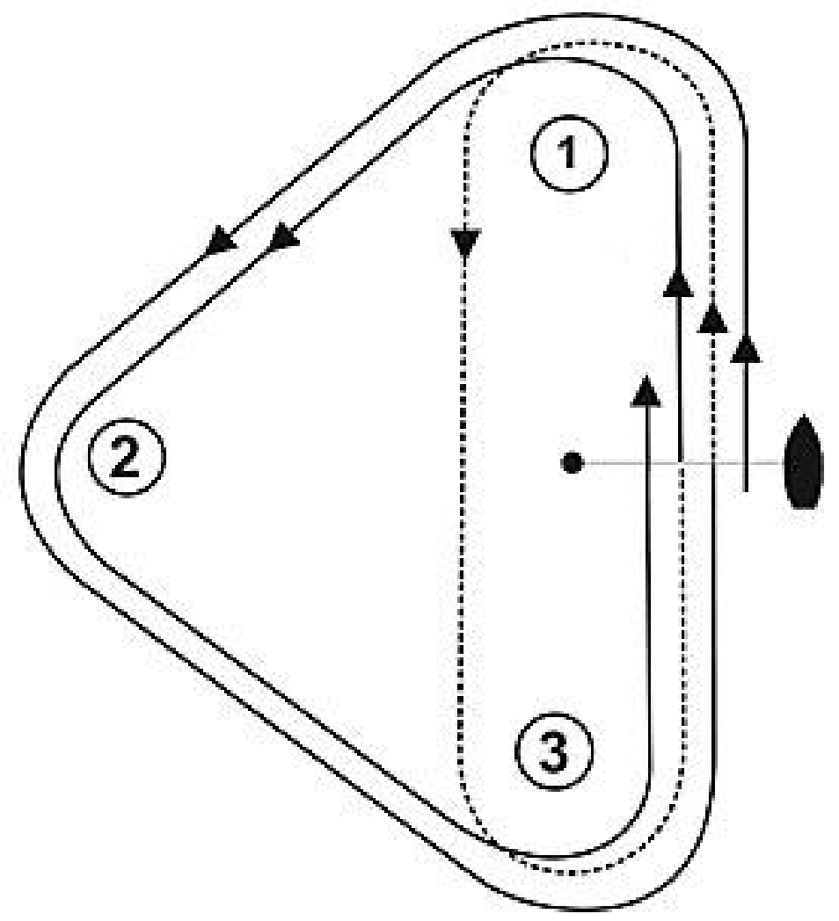
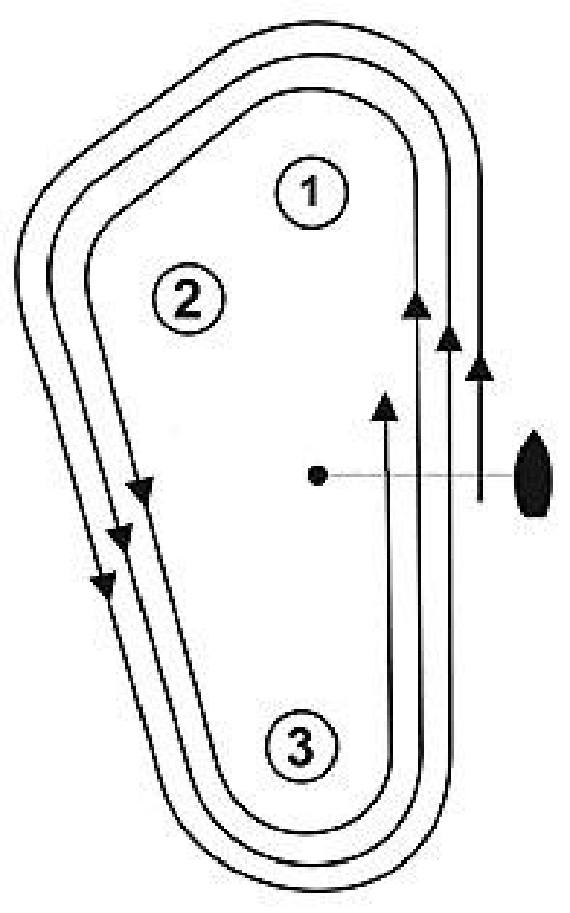 | W/L – Course flag ‘W’  Full and Radial Rigs (as per diagram)  Start - 1 - 2 - 3 - 1 - 2 - 3 - 1 - 2 - 3 Finish  4.7 Rig  Start - 1 - 2 - 3 - 1 - 2 - 3 - Finish

