Sutton Cross Pharmacy
Puppeteer 22 National Championships 2016
Howth Yacht Club
30th & 31st July 2016

Entry Form

Sail No. _______________________ Boat Name ________________________________________________________

Owner ______________________________________________ Club _______________________________________

Address ____________________________________________________________________________________________

Contact No. ___________________________ Email ______________________________________________________

Entry Fee
Tick box (es) & enter total amount
Early Entry Fee (on or before 27th July) | € 50 |  | Total € __________
Entry Fee (after 27th July) | € 60

I enclose Debit / Credit Card details / Cheque payable to Howth Yacht Club Ltd.

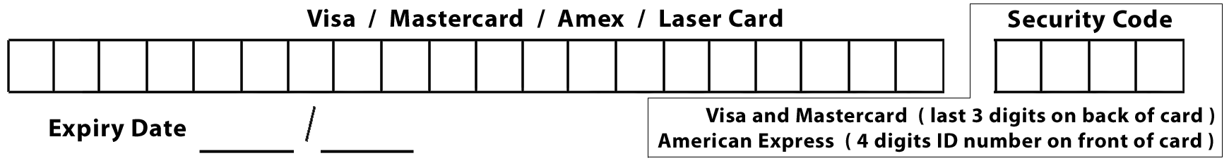

I agree to be bound by the Racing Rules of Sailing, the Prescriptions of the ISA, the Notice of Race, the Sailing Instructions, any amendments thereto and the relevant class rules. I further agree that in the event of any breach of the said rules, sailing instructions or other regulations on my part or on the part of my crew resulting in damage or injury to any other competitor’s boat, person or crew that I will be liable for all damages resulting there from and will indemnify the Organiser of this event against any claim arising from such breach or the consequences thereof.

I acknowledge that I enter and sail at my own risk and that neither the Sponsors nor Howth Yacht Club Ltd will be liable for any loss or damage to boats or equipment or injury to persons.

Identification of Risks
I am fully aware and conscious of the actual and potential risks involved in active water sports, including drowning, hypothermia, and other physical injuries. I accept that, by engaging in active water sports, my physical safety and that of my crew could be endangered, I am also aware that other competitors’ actions, and the actions or inaction of the organisers of water sports events, including the drivers of escort craft, can also endanger my physical safety.

Acknowledgement of Risk
I acknowledge that it is up to me personally to assess whether any event or activity on the water is too difficult for me. I acknowledge that the safety of my boat and her entire management including insurance is my sole responsibility, and I am satisfied the boat and crew are adequate to face the conditions that may arise in the course of the races. I acknowledge that use of Howth Yacht Club Marina Berth/ Mooring is at my own risk. I confirm that my boat carries adequate valid, third party, liability insurance cover.

SIGNED: ____________________________ DATE: ____________________

Entry form with correct remittance should be sent to Kieran Barker, C/O Howth Yacht Club, Harbour Road, Howth, Co. Dublin, not later than Wednesday 27th July 2016.

Prize giving will take place after racing on Sunday 31st July

