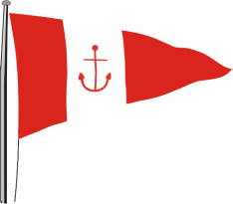 | HOWTH YACHT CLUB  LAMBAY RACES  Organised by Howth Yacht Club Ltd.  Saturday 4thJune 2016
Entry Form

Enter online at www.hyc.ie or send this form, together with cheque or credit card details and IRC certificate to:
The Club Manager, Howth Yacht Club Ltd., Harbour Road, Howth, Co. Dublin.
Class ______________________ Sail No. _________________ Boat Name ____________________________________

Boat Type (Cruisers)_____________________________________ LOA (m) _____________ LWL (m) ____________

Owner _________________________________________ Club __________________________________________

Address _______________________________________________________________________________________________

Contact Telephone number during Regatta _____________________________________

Email ____________________________________________________________________

Classes 1, 2, 3, Non-Spinnaker and One-Designs
YES NO YES NO
Do you have a current IRC Certificate? Is your current IRC certificate enclosed?
Are you registered with ISA for ECHO? (Where relevant)

I enclose Laser / Credit Card details / Cheque payable to Howth Yacht Club Ltd., for the following:
Classes 1, 2 ,3 & Non-Spinnaker € 50.00 (Tick appropriate box)
One-Design Classes € 40.00
Late Entry Fee (after Wednesday 1st June 2016) additional € 10.00 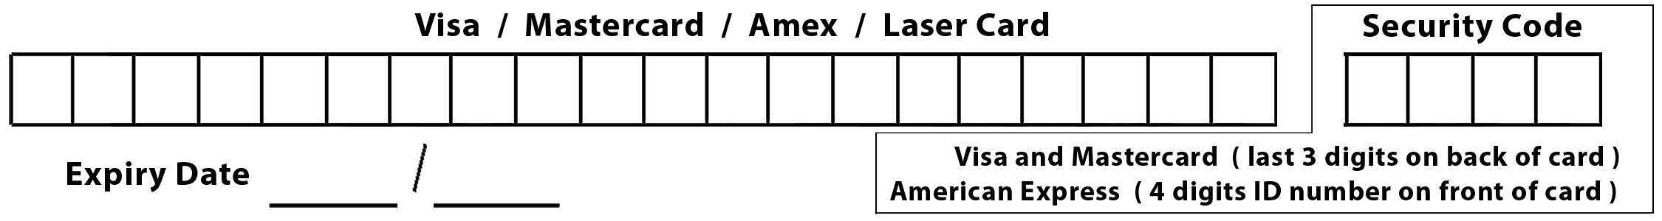

Marina Accommodation
Circle below if you require marina accommodation
Select: Fri Overnight / Fri Overnight + After Racing / After Racing / Sat Overnight / Both Overnights
I acknowledge that use of Howth Yacht Club Marina berth is at my own risk. Boats that have entered the Sportsboat Cup (27th – 29th May) and the Irish Cruiser Racing Association National Championships (10th – 12thJune) will be afforded berthing/dry storage free of charge for the intervening weeks at Howth Yacht Club.

I declare that:
- I agree to be bound by “Racing Rules of Sailing 2013 - 2016” and by all other rules that govern this event.
- I agree to waive any claim for loss, damage or personal injury against Howth Yacht Club Ltd. and any individual or body concerned with this event and to indemnify Howth Yacht Club Ltd., their servants or agents, against all actions, proceedings, claims, costs and demands arising out of the organisation of this event.
- I confirm that my boat carries adequate and valid third party liability insurance cover.
- ECHO Handicap Division only: I understand that the letter and spirit of ECHO requires that owners make the necessary disclosure where there has been a material change in their boat or regular crew and I undertake to comply with this requirement.
- I acknowledge that it is my responsibility to brief all participating crew of the above entered yacht with regard to these declarations

Signed ________________________________ (Owner / Owner’s Representative) Date ____________________

Entry cut-off Wednesday (2200) 1st June 2016. Entries received after this date will be accepted at the OA’s discretion.

