GP14 Class Autumn Open
& Youth Championships

13th & 14th September 2014
Howth Yacht Club

SAILING INSTRUCTIONS

1 RULES

1.1 The event will be governed by the “Rules” as defined in The Racing Rules of Sailing 2013 – 2016 edition (RRS).
1.2 The prescriptions of the ISA will apply. The organising authority is the GP14 Class Association of Ireland and the event is run in conjunction with Howth Yacht Club.
(i) All helmsmen/women for the Autumn Open must be members of the GP14 Class International Association and a member of their national sailing authority or a club affiliated to their national sailing authority. This does not apply to the Youths Championship.
(ii) All boats must have a valid Class Certificate issued prior to the date of the event.

2 NOTICES TO COMPETITORS

Notices to competitors will be posted on the Official Notice Board located in the archway beside the Marina Office.

3 CHANGES TO SAILING INSTRUCTIONS

Any change to the sailing instructions will be posted before 09:00 on the day it will take effect, except that any change to the schedule of races will be posted by 20:00 on the day before it will take effect.

4 SIGNALS MADE ASHORE

4.1 Signals made ashore will be displayed on the flagpole at the top of the marina bridge.
4.2 When flag AP is displayed ashore, ‘1 minute’ is replaced with ‘not less than 45 minutes’ in the race signal AP.

5 SCHEDULE OF RACES

5.1 Dates and times of racing:

13th September, Autumn Open Race 1: Warning Signal 11:00 Race 2 as soon as possible after Race 1

Youths Race 1 & 2 as soon as possible after finish of Autumn Open Race 2, crew changes on the water

14th September, Youth Race 3: Warning Signal 10:30 Race 4 as soon as possible after Race 3

Autumn Open races 3 & 4 as soon as possible after finish of Youth Race 4, crew changes on the water

Tides: Saturday H.W. 15:17, Sunday H.W. 16:03

5.2 Number of races:
Class Number Races per day
Autumn Open 4 2 per day
Youths Championship 4 2 per day

One extra race per day may be sailed, provided that the event does not become more than one race ahead of schedule.
5.3 On the last day of the regatta no warning signal will be made after 15:30 except when a general recall has been signalled.

6 CLASS FLAGS

Class flags will be:
Class Flag
GP14 GP14 Class Flag
Youths GP14 Class Flag

7 RACING AREAS

The waters north and west of Ireland’s Eye

8 THE COURSES

The diagram below shows the intended courses.

Code flag O (Olympic)
Marks to be rounded in the following order: Start - 1 - 2 - 3 - 1 - 3 - 1 - 2 - 3 - - Finish
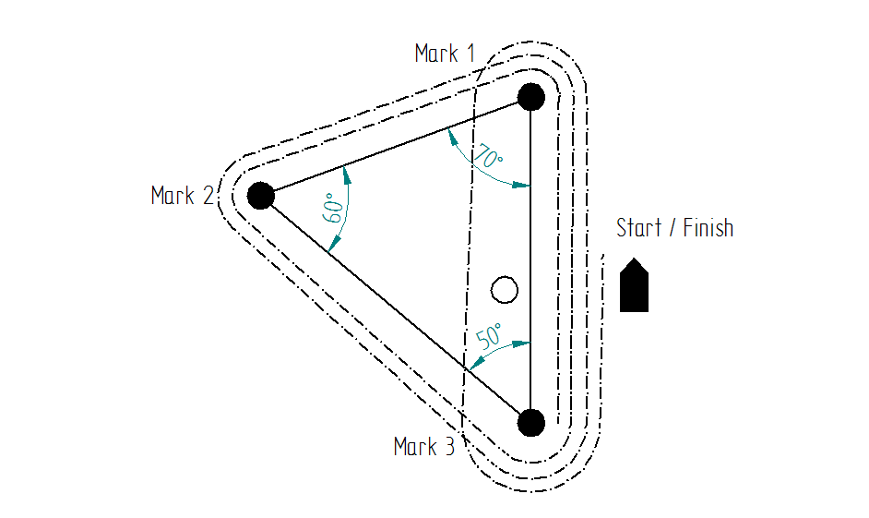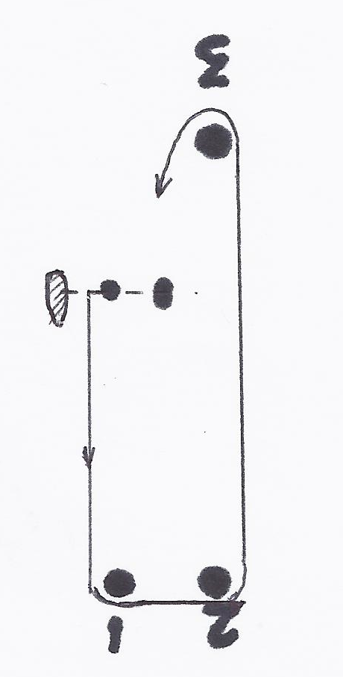
Code flag W (Windward Leeward)
Marks to be rounded in the following order: Start – 1 - 2– 3 – 1 – 2 – 3 – Finish
NOTE: Boats are NOT required to pass through the start/finish line when sailing from mark 3 to mark 1

9 MARKS

Marks 1, 2, and 3 will be Black Inflatable marks. The Starting Mark will be an orange pillar mark.
The Finish Mark will be an orange cherry mark

10 THE START

10.1 Races will be started by in accordance with rule 26 with the warning signal given 5 minutes before the starting signal.

10.2 The starting line will be between red and white pole on the committee boat and the outer limit mark. After starting and prior to finishing, the start line extremities will become obstructions.

10.3 If flag U has been displayed as the preparatory signal, no part of a boat’s hull, crew or equipment shall be in the triangle formed by the ends of the starting line and the first mark during the last minute before her starting signal. If a boat breaks this rule and is identified, she shall be disqualified without a hearing but not if the race is restarted or resailed or postponed or abandoned before the starting signal. This changes rule 26 Starting Races and RRS 63.1.
10.4 A boat starting later than 5 minutes after her starting signal will be scored Did Not Start. This changes rule A4.

11 CHANGE OF THE NEXT LEG OF THE COURSE / SHORTENING THE COURSE

11.1 To change the next leg of the course, the race committee will move the original mark (or the finishing line) to a new position.
11.2 As an addition to rule 32.2, the race committee may decide to use the start/finish area to shorten the course. In this case a craft may be positioned near Mark 3 displaying Flag “F” and making sound signals.

12 THE FINISH

The finishing line will be between red and white pole on the committee boat and an outer limit mark. When on station the committee boat will display a blue flag.
NOTE: The Starting Mark may be in position during the finish.

13 TIME LIMITS

13.1 Time limits are as follows:
Class Time limit
All races 90 minutes

13.2 Boats failing to finish within 15 minutes after the first boat sails the course and finishes, will be scored as per their position at the previous mark. This amends the definition of the word "Finish". The purpose of this sailing instruction is to reduce the delay between races when multiple races are scheduled. This changes rules 35 and A4.

14 PROTESTS AND REQUESTS FOR REDRESS

14.1 Protest forms are available at the race office. Protests shall be delivered there within the protest time limit.
14.2 The protest time limit is 90 minutes after the last boat has finished the last race of the day and this time will be posted on the official notice board. The same time limit applies to protests by the race committee and protest committee about incidents they observe in the racing area and to requests for redress. This changes rules 61.3 and 62.2.
14.3 Notices will be posted within 30 minutes of the protest time limit to inform competitors of hearings in which they are parties or named as witnesses. Hearings will be held in the Centenary Room.
14.4 Notices of protests by the race committee or protest committee will be posted to inform boats under rule 61.1(b).
14.5 A list of boats that, under instruction 14.4, have acknowledged breaking rule 42 or have been disqualified by the protest committee will be posted before the protest time limit.
14.6 Breach of instruction 16.1 will not be grounds for a protest by a boat. This changes rule 60.1(a). Penalties for this breach may be less than disqualification if the protest committee so decides.
14.7 On the last day of the regatta a request for reopening a hearing shall be delivered
(a) within the protest time limit if the party requesting reopening was informed of the decision on the previous day;
(b) no later than 30 minutes after the party requesting reopening was informed of the decision on that day.
This changes rule 66.

15 SCORING

15.1 The scoring system will be the Low Point System.
15.2 A minimum of 1 race is required to be completed to constitute a series.
15.3 (a) When fewer than 4 races have been completed, a boat’s series score will be the total of her race scores.
(b) When 4 races have been completed, a boat’s series score will be the total of her race scores excluding her worst score.

16 SAFETY REGULATIONS

16.1 Check out and check in:
A tag board with numbered wristbands will be located near the launching area. Immediately before going afloat, competitors (helm and crew) should remove their numbered wristband and wear it until coming ashore.

On returning ashore, each crewmember replaces the wristband indicating that they have returned safely.

Failure to observe the safety tag system as described above may result in disqualification by the race committee, unless a donation of €10 to the RNLI is paid to the Race Office.
16.2 A boat that retires from a race shall notify the race committee as soon as possible.

17 REPLACEMENT OF CREW OR EQUIPMENT

Substitution of competitors will not be allowed without prior written approval of the race committee.
18 EQUIPMENT AND MEASUREMENT CHECKS

A boat or equipment may be inspected at any time for compliance with the class rules and sailing instructions.

19 PRIZES

Prizes will be awarded to 1st, 2nd and 3rd overall in each of the Gold, Silver and Bronze fleets.
Prizes will be awarded for the Youth Championships Under 23, Under 21 and Under 16 depending on numbers.
GP14 Class perpetual trophies will be awarded to the overall winners of the Autumn Open and Youth Championships

20 DISCLAIMER OF LIABILITY

Competitors participate in the Championship entirely at their own risk. See rule 4, Decision to Race. The organizing authority, or the event sponsors, will not accept any liability for material damage or personal injury or death sustained in conjunction with or prior to, during, or after the regatta.

21 INSURANCE

Each participating boat shall be insured with valid third-party liability insurance with a minimum cover of € 1,270,000 per event or the equivalent.

