HOWTH YACHT CLUB
Club Championships
Organised by Howth Yacht Club.
Sunday 20th July 2014
Entry Form

Send this form, together with damage deposit details to:
Sailing Secretary, Howth Yacht Club, Harbour Road, Howth, Co. Dublin.
Nominated Helm : _______________________________________________ YES NO

Nominated Crew 1 _______________________________________________ Member HYC

Nominated Crew 2 _______________________________________________ Member HYC

Nominated Crew 3 _______________________________________________ Member HYC

Note :- One of the three nominated crew must be members of HYC

Nomination from one of the following classes:- (Please Tick)

Class 0 Cruising Group Other (Give Details)

Class 1 J24 Laser Class (Senior) __________________________

Class 2 Puppeteer 22 Laser Radial

Class 3 Squib 420 Class

White Sail Howth 17 Optimist

NB – AS PER SAILFLEET RULES - A €1,000.00 DAMAGE DEPOSIT IS REQUIRED FROM EACH ENTRY.

DAMAGE TO THE J80 - Damage forms must be returned to the race office and apportioned damages paid before the damage deposit is released at the end of the event.

Visa / Mastercard / American Express / Laser Card - Number Expiry Date
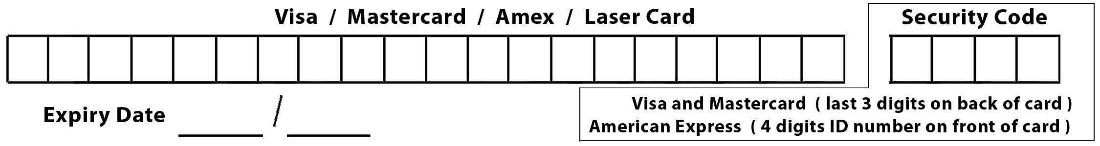

I declare that:
- I agree to be bound by ‘The Racing Rules of Sailing’ and by all other rules that govern this event.
- I agree to waive any claim for loss, damage or personal injury against Howth Yacht Club, HYC Events Ltd. and any individual or body concerned with this event and to indemnify Howth Yacht Club, their servants or agents, against all actions, proceedings, claims, costs and demands arising out of the organisation of this event.
- I confirm my damage deposit of €1000 and agree that any apportioned damages will be paid before damage deposit will be released.

Signed ________________________________ (Nominated Helm) Date ____________________
To be signed by Parent/Guardian, if under 18 years old on 19th July 2014

