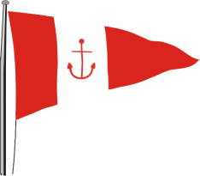 | HOWTH YACHT CLUB  LAMBAY RACES  Saturday 7th June 2014  Supplementary Sailing Instructions for Howth 17s & Old Gaffers

(Sponsored by Bryan Lynch & Harriette Lynch of Echo)

- Warning Signal
The Warning Signal for the Howth 17s will be at 11.25.
The Warning Signal for the Old Gaffers will be the Start Signal for the Howth 17s.

- Courses
Course numbers will be displayed on the starter’s hut on the East Pier. The courses are set out in the table below:
No. 1 | East going to Thulla (J) to port, Lambay to port, Finish at Committee Boat at X Mark in the Sound
No. 2 | East going to Thulla (J) to port, Lambay to starboard, Finish at Committee Boat at X Mark in the Sound
No. 3 | West going, Lambay to port, Finish at Committee Boat at X Mark in the Sound
No. 4 | West going, Lambay to starboard, Finish at Committee Boat at X Mark in the Sound

The Spit Mark must be passed to port heading north and passed to starboard heading south.

- Class Flags
Howth 17s Flag C; Old Gaffers: Flag F.

- Start Line
The start line will be between the Red line on the East Pier Starter's Hut and the yellow start mark - "FA" as per the map in the main SIs.

- Finish Line
Unless the course is shortened the finish line will be at the Xebec Mark – “FB” as per the map in the main Sis.
This is also the finish line for the Inshore Fleet.

