SEPA DIRECT DEBIT MANDATE  *UNIQUE MANDATE REFERENCE | 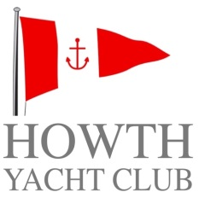
*CREDITOR IDENTIFIER: IE30ZZZ306982
Legal Text: By signing this mandate form, you authorise (A) Howth Yacht Club to send instructions to your bank to debit your account and (B) your bank to debit your account in accordance with the instruction from Howth Yacht Club. As part of your rights, you are entitled to a refund from your bank under the terms and conditions of your agreement with your bank. A refund must be claimed within 8 weeks starting from the date on which your account was debited. Your rights are explained in a statement that you can obtain from your bank. Please complete all the fields below marked *
*Your Name :

Your Address:

*City/postcode * Country:
* Account number(IBAN)

*Swift BIC

COMPANY NAME: Howth Yacht Club CLG
COMPANY ADDRESS: Middle Pier, Harbour Road
HOWTH
CO DUBLIN.

*Type of payment Recurrent or One-Off Payment (Please tick √)
*Date of signing:

*Signature(s)

PLEASE RETURN COMPLETED FORMS TO:
ADMINISTRATION OFFICE
HOWTH YACHT CLUB CLG
MIDDLE PIER
HARBOUR ROAD
HOWTH
CO DUBLIN.

