***Howth Yacht Club ‘Introductory Membership’ 2017***

* Annual Introductory Membership permits the use of the Club from **1st January to 31st December**
* Introductory Members are encouraged to use the ‘top up’ facility on their Membership Cards for use at the bar and in the club offices
* Introductory Members enjoy members’ discounted pricing throughout the club.
* This category of membership is limited to candidates who have not been an Ordinary Member of Howth Yacht Club since 31st December 2013
* The completed application form is sent to the Honorary Secretary along with a letter of recommendation from proposer or Membership Committee
* As Membership for the Club runs from January to December, your membership will be due for renewal at the start of each calendar year

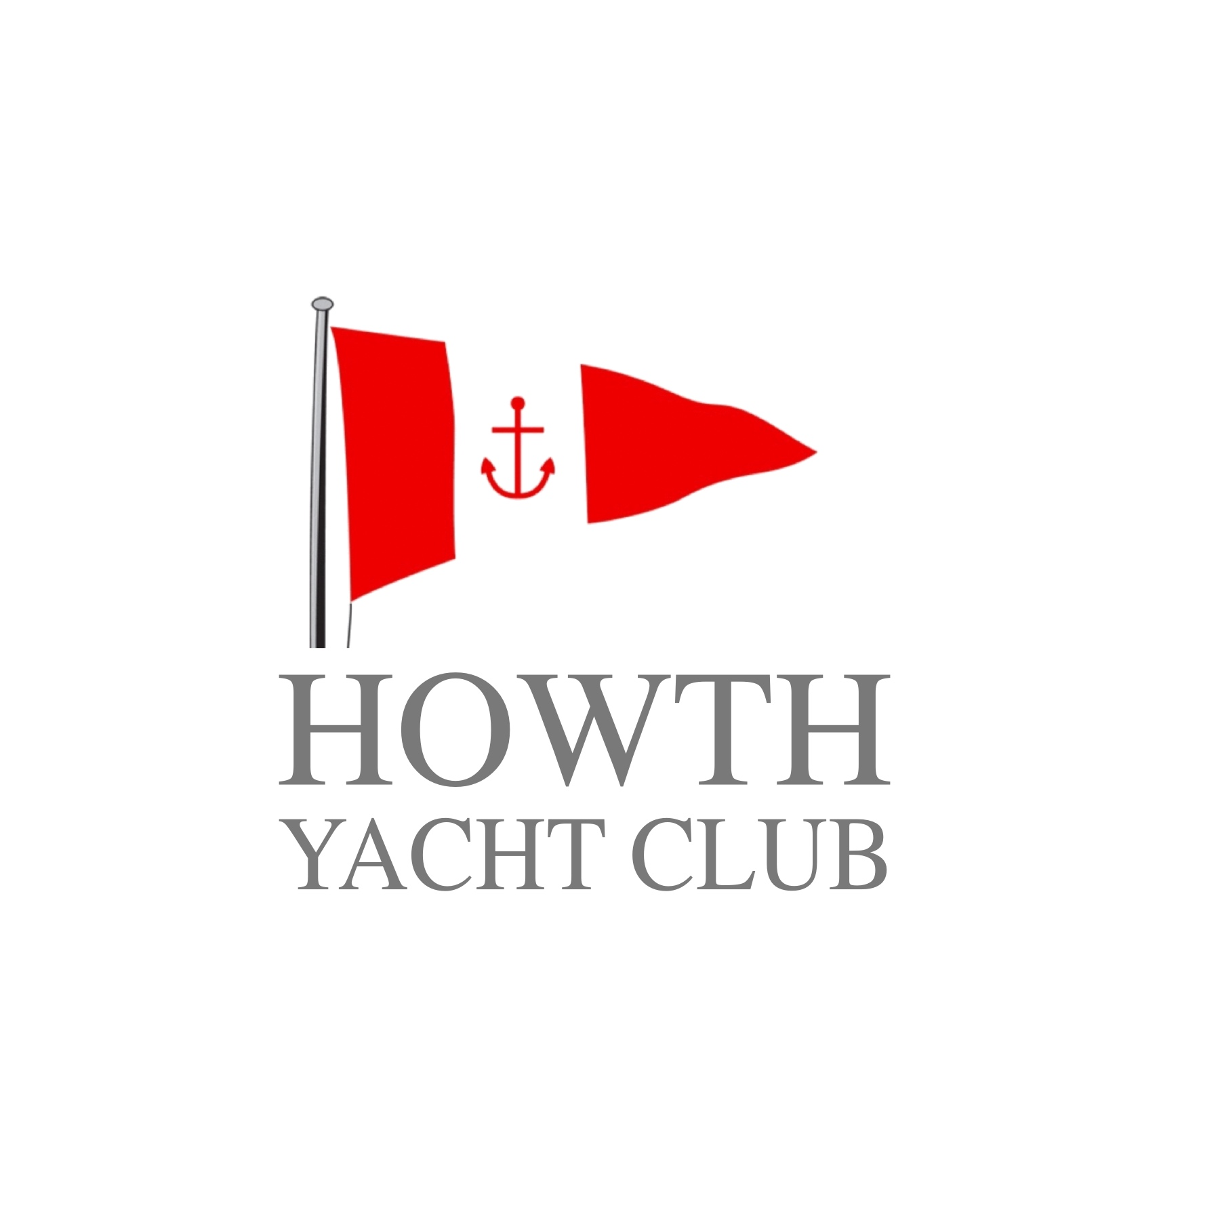

**Introductory Membership Form**

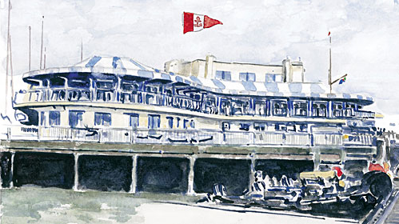

***Introductory Membership 2017***

***€300***

***For more information please contact:***

***Howth Yacht Club***

***Middle Pier***

***Howth***

***Co Dublin***

***01 832 2141***

[***office@hyc.ie***](mailto:office@hyc.ie)

***hyc.ie***

Have you previously been a member? If so, give details:

Full Name

Address

PAYMENT DETAILS:

Please find enclosed Cheque Cash

IN THE AMOUNT OF €300.00

Please debit my Amex / Mastercard / VISA / VISA DEBIT

EXPIRY CCV

Signature

Date

For Office Use Only:

Please list members of your family who are HYC Members: (if any)

Date of Birth

Occupation

Company

Mobile

Please list other Yacht Clubs of which are are a member: (if any)

Daytime no.

Email

Please give a brief history of your sailing experience and/ or aspirations:

Insert photo here

Did you present yourself for interview by the Membership Committee (if no Proposer)?

SIGNED BY MEMBERSHIP COMMITTEE

SECONDER

**SIGNATURE**

**BLOCK CAPITALS**

**SIGNATURE**

**BLOCK CAPITALS**

PROPOSER

**YES / NO**

DATE COMPLETED

**DATE CLEARED FOR THE NOTICEBOARD**

**DATE RECEIVED**

**DATE OF ELECTION**

**MEMBERSHIP NUMBER / FAMILY ID / WEB ID**

OF THE GENERAL COMMITTEE

RECOMMENDED AND SIGNED BY

**ON BEHALF OF THE GENERAL COMMITTEE**

**ON BEHALF OF MEMBERSHIP COMMITTEE**

(PROPOSER MUST ENCLOSE LETTER OF RECOMMENDATION)