***Howth Yacht Club Membership 2017***

*Every candidate for Ordinary, Associate, Cadet or Country Membership must be 18 years of age and must be proposed and seconded by an Ordinary, Honorary or Senior Member, to both of whom he or she has been personally known for at least one year, and the candidate must also be known to, and recommended by, a member of the General Committee.*

*Completed application form, together with letter of recommendation from proposer, shall be sent to the Honorary Secretary. As Membership for the Club runs from January to December, your Membership is due for renewal at the start of the calendar year.*

***SENIOR*** *- is open to members who have 10 years continuous Ordinary membership and are aged 66 years or over.*

***ASSOCIATE*** *- is open to candidates who are spouses, widows or widowers of Honorary, Senior or Ordinary Members.*

***CADET*** *- is open to candidates 19 to 24 years of age inclusive.*

***JUNIOR*** *– is open to candidates 7 to 18 years of age inclusive.*

***COUNTRY*** *- is open to candidates who are resident outside a radius of 60 kilometres of Howth or who are voting members of any Yacht Club with which Howth Yacht Club has a reciprocal membership agreement.*

***FAMILY*** *- is made up of one Ordinary member, one Associate member and unlimited Junior members all from the same family.*

***2017 Introductory*** *– is limited to candidates who have not been an ordinary member since 31st December 2013.*

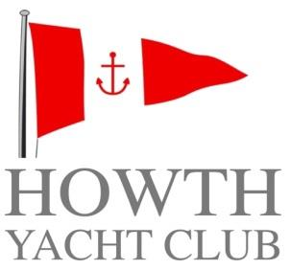

**Family**

**Membership Application Form**

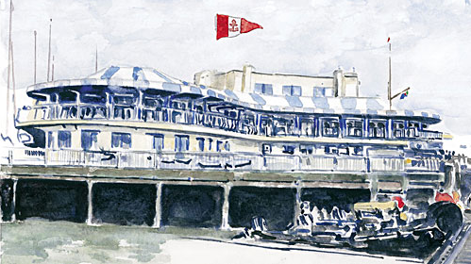

**SUBSCRIPTION RATES 2017**

**FAMILY €1100.00**

**ORDINARY (Over 32 years) €820.00**

**ORDINARY ((aged 30 & over 31) €525.00**

**ORDINARY (aged 28 & 29) €340.00**

**ORDINARY (aged 25 to 27) €175.00**

**ASSOCIATE €210.00**

**CADET (aged 19 to 24 inclusive) €125.00**

**COUNTRY €240.00**

**OVERSEAS €50.00**

**SENIOR €400.00**

**JUNIOR €105.00**

**2017 Introductory €300.00**

**(T&Cs apply)**

***For more information please contact***

***Howth Yacht Club***

***Middle Pier, Harbour Road***

***Howth***

***Co Dublin***

***01 832 2141***

[***office@hyc.ie***](mailto:office@hyc.ie)

***hyc.ie***

**Email**

PAYMENT DETAILS

Please find enclosed Cheque Cash

IN THE AMOUNT OF €

Please debit my Amex / Mastercard / VISA / VISA DEBIT

**EXPIRY CCV**

**Signature**

**Date**

For Office Use Only

**Member Yes / No**

**Date of Birth**

**Full Name (ORDINARY)**

**Mobile No.**

**Address**

**Daytime No.**

**Full Name (ASSOCIATE)**

**Date of Birth**

**Member Yes / No**

**Member Yes / No**

**Date of Birth**

**(Junior) Applicant 1 Full Name**

**Sailing experience / ISA Level Achieved**

**(Junior) Applicant 2 Full Name**

**Member Yes / No**

**Date of Birth**

**Sailing experience / ISA Level Achieved**

**Member Yes / No**

**Date of Birth**

**(Junior) Applicant 3 Full Name**

**Sailing experience / ISA Level Achieved**

**Please give a brief history of your Sailing experience or and aspirations.**

**DATE RECEIVED**

**DATE CLEARED FOR THE NOTICEBOARD**

**DATE OF ELECTION**

**MEMBERSHIP NUMBER / FAMILY ID / WEB ID**

**Date approved**

OF THE GENERAL COMMITTEE

RECOMMENDED AND SIGNED BY

**SIGNATURE**

SECONDER

**BLOCK CAPITALS**

SECONDER

**SIGNATURE**

PROPOSER

**BLOCK CAPITALS**

PROPOSER

**Please list other Yacht Clubs of which you are a Member, if any.**

PROPOSER PLEASE ENCLOSE LETTER OF RECOMMENDATION