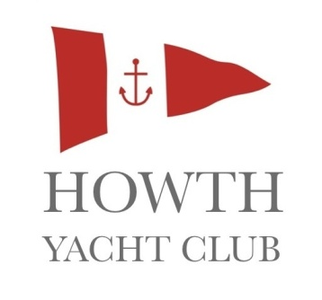
YOUTH ADVENTURE SAILING
Howth Yacht Club is offering its teenage members and their friends an opportunity to develop their sailing skills in a friendly, relaxed environment. Weather permitting, all training including briefings and theory will take place onboard the Club’s fleet of J80 keelboats.
If you have a group of friends who have already learnt to sail dinghies and have spent some time sailing keelboats together, why not book an Adventure sailing course this Summer?
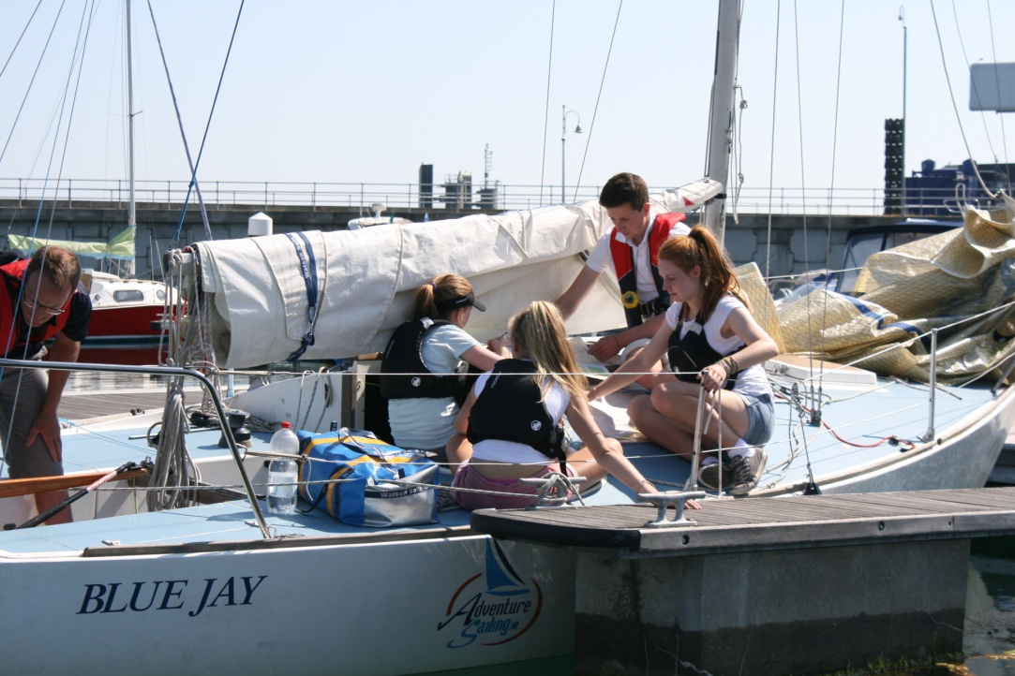
THE CHALLENGES
- Work together as a team of 3-5 sailors with an instructor.
- Plan passages to destinations like Skerries, Lambay Island, Malahide, Dun Laoghaire or Greystones.
- Confidently and safely sail a J80 on longer trips away from your local club.
- Get involved in planning daily activities that cater for the interests of the crew on your boat.
- Develop the necessary skills that will enable you to make longer trips and play an active role in cruising holidays.

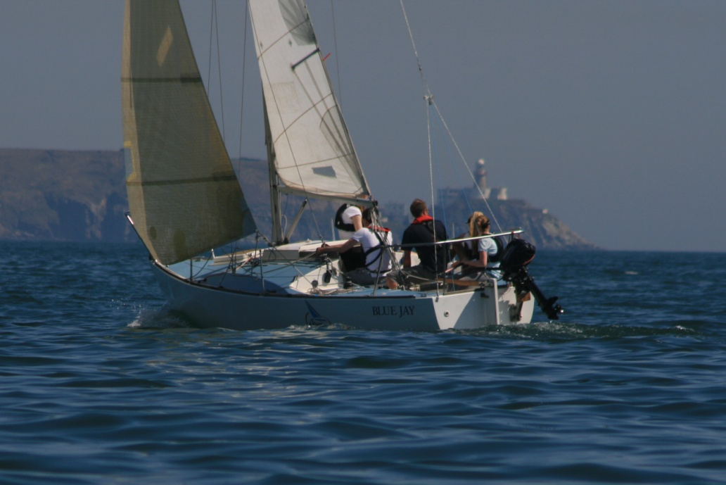
THE REWARDS
- Learn how to safely plan and carry out a day trips outside your local area.
- Visit interesting harbours and anchorages along the Dublin coastline.
- ISA Keelboat Certificates up to Adventure 1 & 2 level.

