“Aslana” is a 6.6 metre sloop designed by E. G. Van de Stadt, and built by Rydgeway Marine in 1974. She's equipped for single or short handing; the majority of her lines come back to the cockpit via two triple clutches with self-tailing winches. Her cockpit winches are also self-tailing Antals. All standing rigging was changed in December 2012, as were the mast and boom. A Furlex system for the genoa was added at the same time. The genoa and main were replaced in April 2013, the gennaker and spinnaker have not been changed.
She comes with a 5 HP outboard engine that can be stored in the starboard cockpit locker (which is specially reinforced for this purpose), and unlike some smaller yachts, the engine sits inside a well in the cockpit – no leaning over the stern!
Down below, you'll find four 6 foot berths, a small spirit stove (and kettle, perfect for a cup of tea while sailing), a table that stows beneath the cockpit sole, and a cleverly hidden toilet. The battery is kept charged by a solar panel, and there’s masthead VHF antenna cable that can be connected to a handheld VHF radio.
If Aslana isn't for you, but you know of someone looking for a small boat, please put them in contact with me – aslana@cricalix.net / +353879847304. Asking €4250 OBO; includes new Tennamast cradle and DMYC mooring for summer. Boat is in Dun Laoghaire on a DMYC mooring.
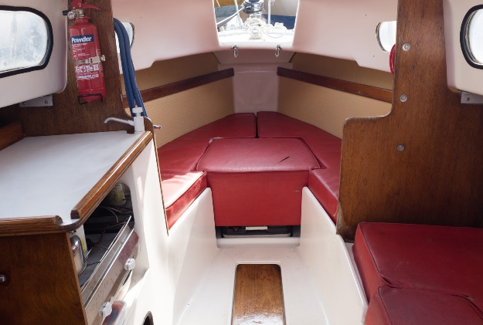 | 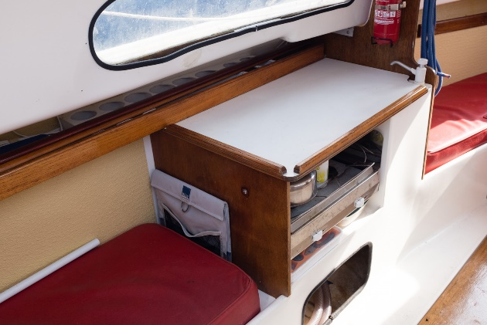
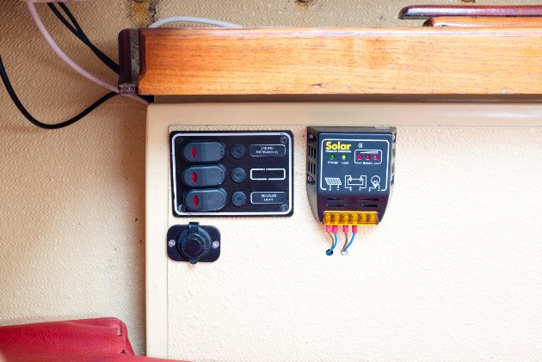 | 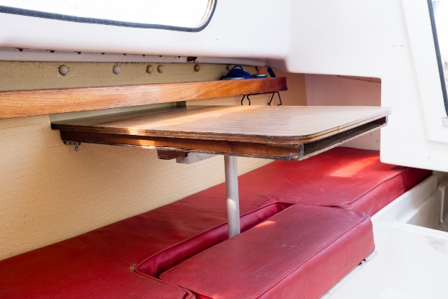
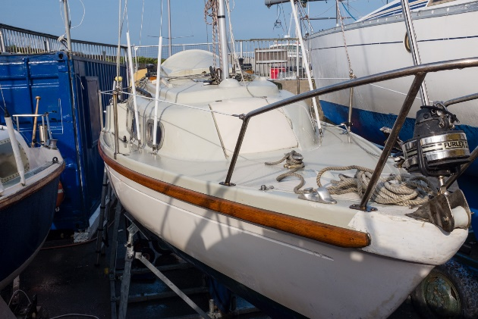 | 