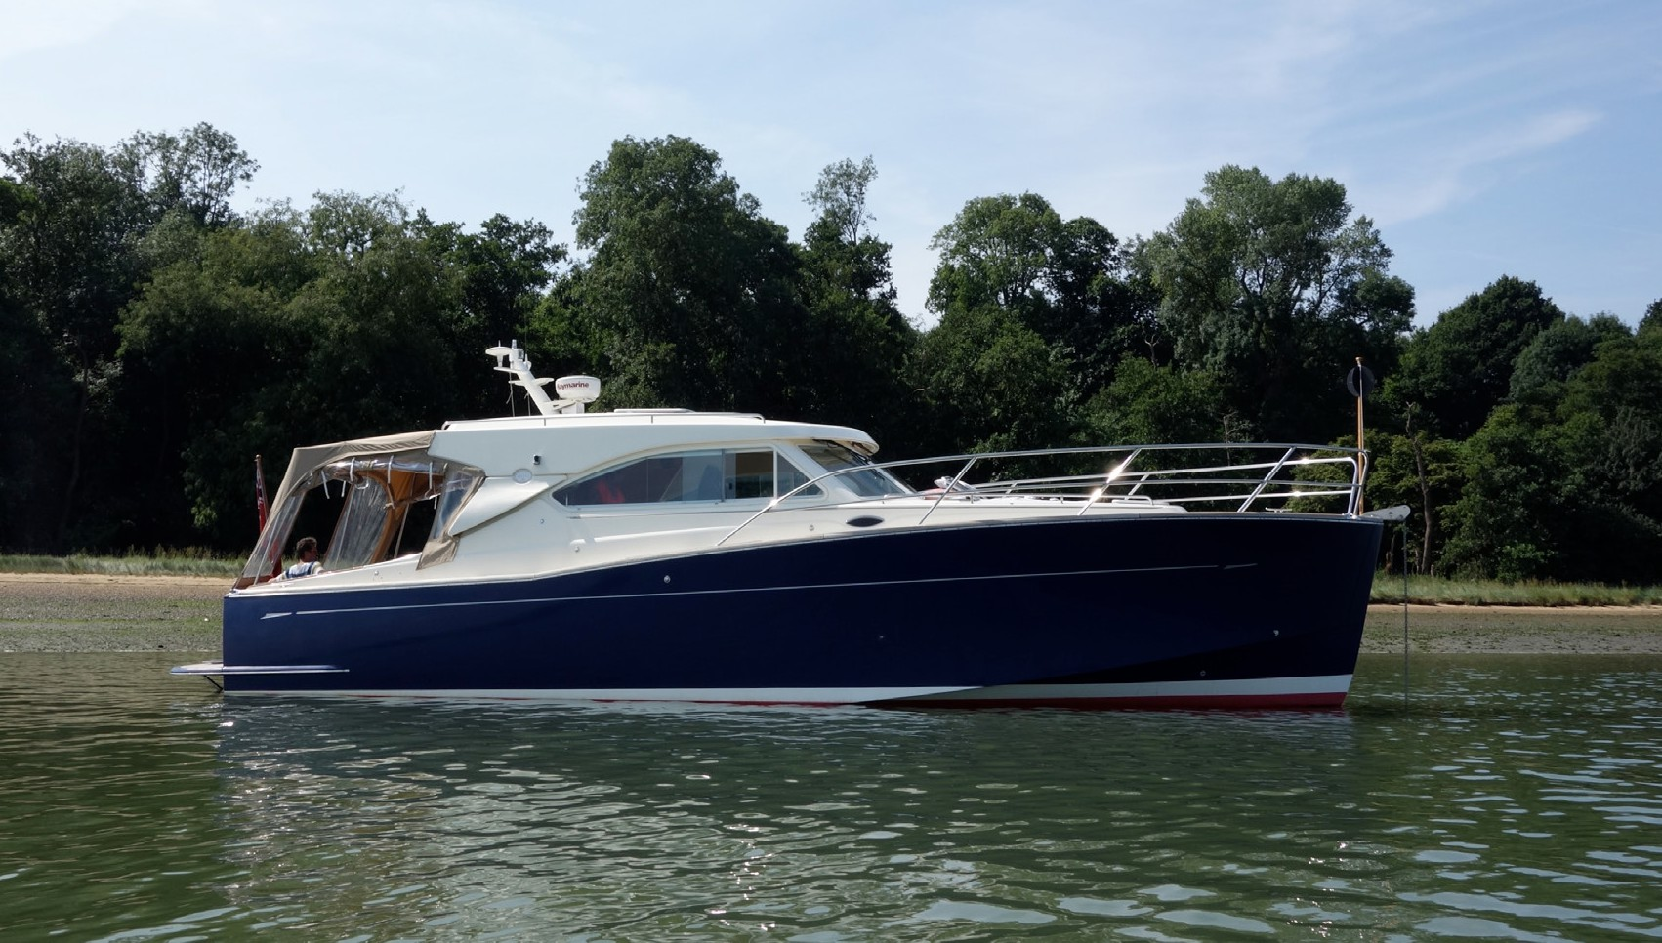

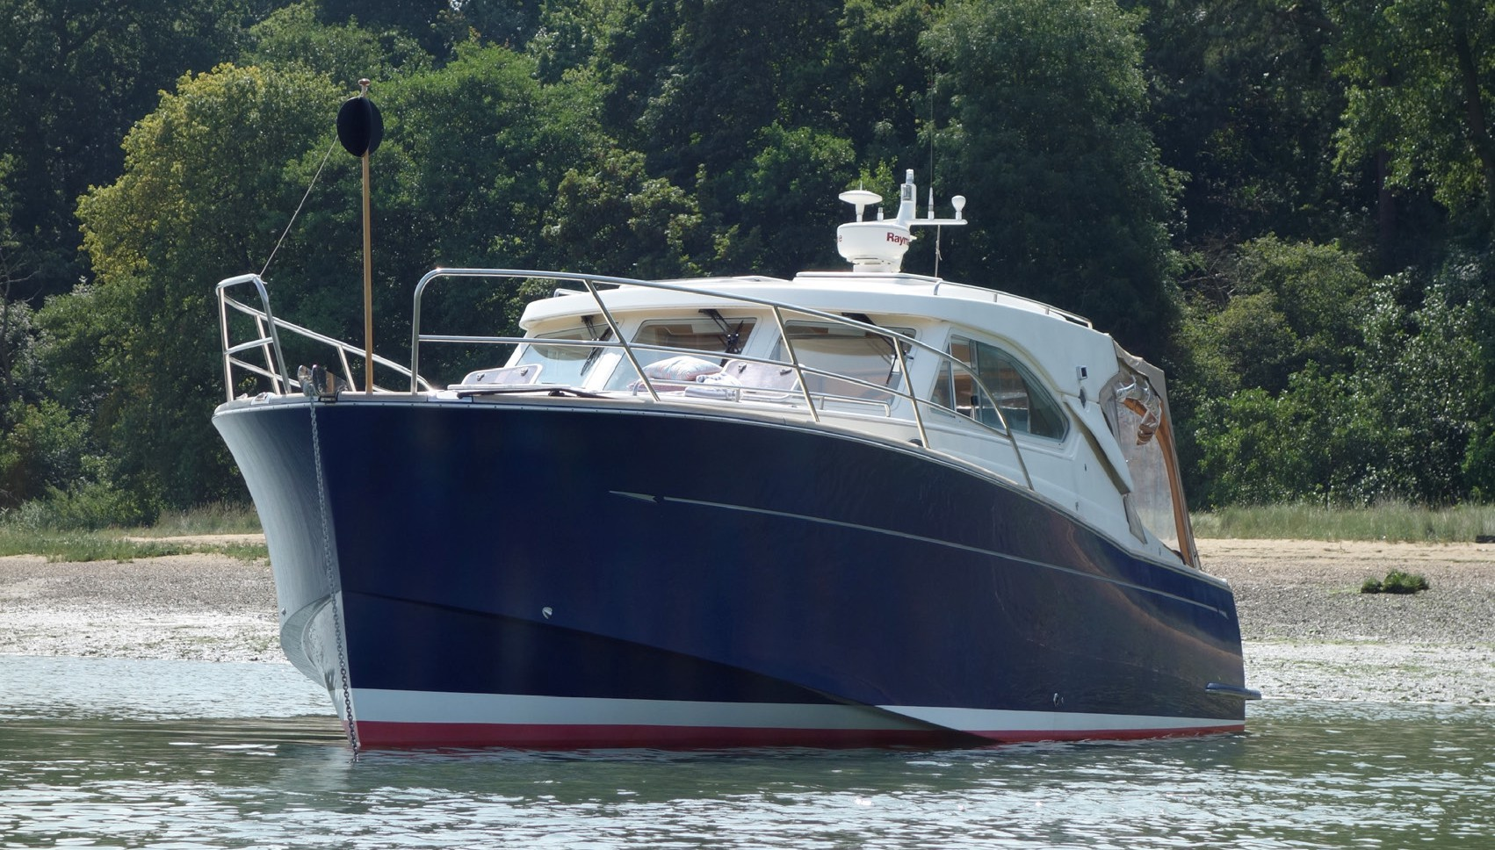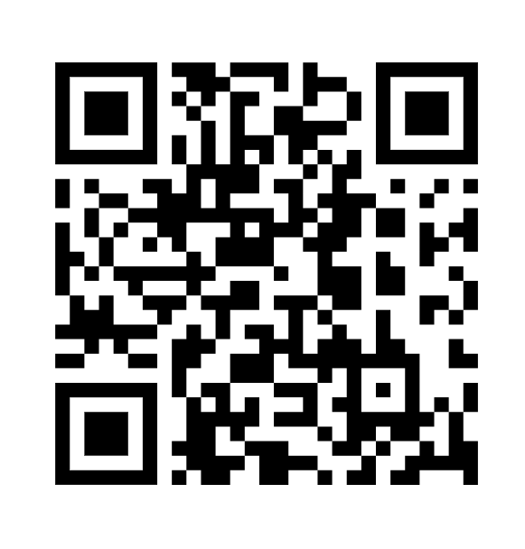

For Sale.

Oyster OM 43

(twin cabin version of Oysters only motor boat)

**t: 0044 7771 628 300**